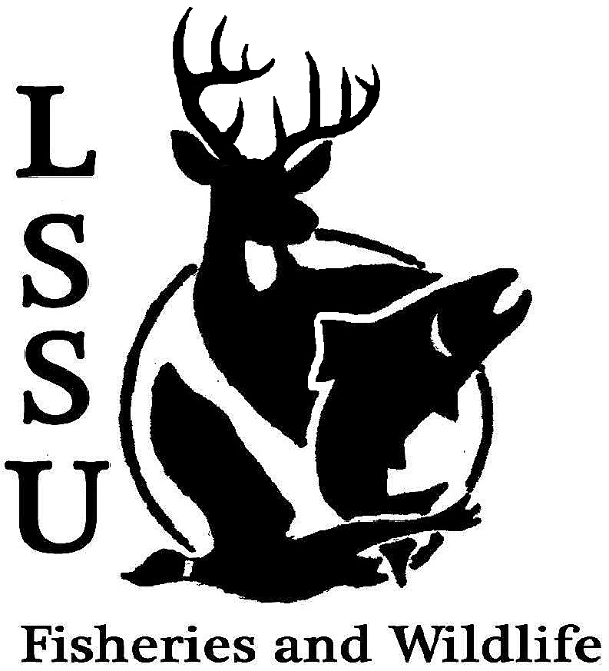
LSSU Fisheries and Wildlife Club
Meeting of November 12th, 2014
Kyle Hafeman: khafeman@lssu.edu (906) 295-1585

- Officers Report
  - Vice President – Jayne Meinhard Nothing to report
  - Secretary – Addie Dutton Presented the minutes from the previous meeting. Motioned for approval first by Logan and second by Nate. Minutes were approved
  - Treasurer – Jake Truitt Reported the current money situation in the account and petty cash. Before paying for catering the Whitefish Dinner total was $2,283. Motion to approve first by Logan and second by Eddie report was approved.
  - Event Committee – Maddy and Gislaine A poll was taken to determine which of the invasive species experts that the club would like events committee to contact about the possibility of a guest lecture or presentation.
  - Raffle Committee – Cliff When you are home over opening day or Thanksgiving try and collect more raffle prizes and thank you for everyone that helped out with the Whitefish Dinner the silent auction was a huge success.

- Old Business
  - Whitefish Dinner This was covered above in both Jake’s report and Cliff’s report. The most successful Whitefish Dinner so far and a big thanks to everyone who helped make it a success!
  - ARL Broodstock Netting Andrew talked about how much of a success this event was and that it was great to learn some skills necessary in the fisheries field. It was discussed among the club how it is the best time of the year at the ARL right now.
  - Ashmun Creek Tree Planting No one attended this event
  - Electrofishing Workshop Rachel talked about how this was such a great experience and that she learned a lot and was a great skill to be able to add to your resume. It was requested that another workshop be done in the future maybe at a larger stream if possible.

- New Business
  - Raffle Donations-Thank You Cards Cliff discussed this earlier and that anyone that can help out should meet this Friday at 4:00pm at Laker Hall.
  - Atlantic Salmon Egg Take-Thursday Nov. 13th 8am-12pm Covered earlier along with broodstock netting that this is the best time of the year at the ARL and anyone that would like to help out please do so. Addie is available to give rides from 11:00-1:30.
  - ARL Newsletters-Friday Nov. 14th 12-3pm at Lukenda House Anyone that isn’t going home for the weekend, could join ARL workers and help fold and tab the ARL newsletters. Dr. Roese will be providing pizza for anyone that helps out.
  - Fly Tying Class at ROC-Tuesday Nov. 18th 7pm This workshop is being hosted by Nome a guide and is being held at the ROC. The cost is $20 and includes taking home one salmon and one trout fly that you get to take home with you.
  - Doug Reeves-Crawford 306, Nov.19th 7:00pm Doug’s visit has been cancelled again, but we will stay in contact with him for the possibility of meeting next semester after he has fully recovered.
  - Midwest F&W and MI AFS Registration for Midwest should be opened soon and if you plan on attending remember that you must be an active member and gotten raffle prizes.
  - Moose Watch and College Intern opportunities at Isle Royale All the information for this program is available on Google. The internship is free, but there is a fee attached with the moose watch portion.
  - Facebook Buck Pole Kyle will have the Buck Pole up tonight on Facebook. It will act the same as the summer fishing tourney.

- Reminders
  - Please take photos at FWC events!
  - Pay your dues!
  - Senior Research?
Next Meeting: Wednesday December 3rd @ 8 PM
Meeting adjourned at 8:27 pm first by James second by Logan all approved

