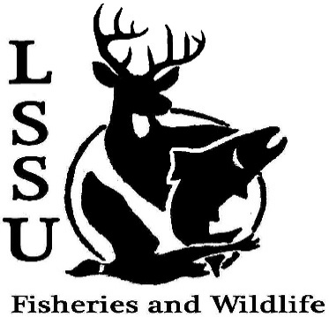
LSSU Fisheries and Wildlife Club
Meeting of February 3rd, 2016
Open at 8:02

Officers
President: Cliff Pattinson: cpattinson@lssu.edu (269) 841-6472
VP: Michelle Kane
Secretary:
Treasurer: John Milan
Events Committee Co-Chairs: Chris Cortell, Matt Grieb, Jake Northius
Fundraising Committee Chairs: Alleigh Sexton, Elizabeth Cilman

- Officer’s Report
  - Vice President – Michelle Kane
  - Secretary – Vacant (Michelle Kane) 1st by Jake, 2nd by Cole
  - Treasurer – John Milan 1st by Mike, 2nd by Cole
- Old Business
  - Midwest Fisheries and Wildlife Conference Cliff described the conference and raffle, Underclassman were recommended to attend in the future, Students like AFS and TWS being combined
- New Business
  - Special Election for Incumbent Secretary
    - ELECTION TONIGHT!
    - Jacob Northius and Katherine Skubik ran
    - Jacob Northius won, begins duties at next week’s officer’s meeting and will be sworn in at next meeting
  - Marine Biology Belize Trip Reflections – Morgan Freebairn, She summarized the highlights of the trip and recommended study abroad
  - Tubing outing – Feb 9th, 6:30 Library Parking lot
  - Heartburn for Kids Chili Cook Off – Feb. 23rd. Will take place from 11-3, need people to work and to make chili
  - Bird ID Workshop – Jake Northuis, Mid to Late Feb. Feb 20th at 12 or 1 pm
  - Resume Workshop– John Milan Details will be finalized after John contacts Dr. Roese
  - Apparel Meet Up
  - Bird Conference – Late March Early April March 17th – 18th in Tustin, MI
  - TWS North Central Student Conclave – April 1-3, Tomahawk WI (Host: University of Wisconsin Stevens Point) Interested students met after the meeting
  - MI TWS Annual Meeting – still TBA Interested students will receive an email with the date when it is announced
  - Sampling with MSU – Later in semester, TBA
  - Possible UP Chapter outing w/ MTU, NMU
  - TWS Student Registration FREE TRIAL
  - Fly Fishing Film Tour led by Fly Fishing Club, looking for volunteers, seniors can put up their posters
  - Openings in Laker Hall next year – Applications due next week
  - Have an idea for an event? Talk to Events Committee or any of the Officers!
  - Have an idea for a Meet and Greet? Talk to Events committee or any of the Officers!
  - Senior Research help? Chris Cortell wants Pike or Muskie heads and stomachs from any water connected to Tahquamenon

- Reminders
  - Please take photos and videos at FWC events!
  - Pay your dues!
  - Like the Facebook page!
  - Visit our Website! http://www.lssufwc.weebly.com/

Next Meeting: February 17th, 2016 @ 8 PM
Close at 8:33, 1st by Jake, 2nd by Ben

