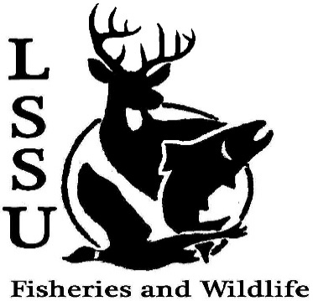
LSSU Fisheries and Wildlife Club
Meeting of October 7th, 2015
Started at 7pm
Officers
President: Cliff Pattinson: cpattinson@lssu.edu (269) 841-6472
VP: Michelle Kane
Secretary: Autumn Wiese
Treasurer: John Milan
Events Committee Co-Chairs: Chris Cortell & Matt Grieb
Fundraising Committee Chair: Alleigh Sexton

- Officer’s Report
  - Vice President – Michelle Kane
  - Secretary – Autumn Wiese 1st by Anthony, 2nd by Chris
  - Treasurer – John Milan 1st by Anthony, 2nd by Cole

- Old Business
  - Pond Sampling Cliff showed a PowerPoint

- New Business
  - Scavenger Hunt! Won-Jake, Mitchell, Ashely, Nick, Matt, Ethan
  - Raffle Blitzes: October 9th and 23rd, 11 AM @ Library Parking Lot
  - Little Traverse Conservancy Clean Up of Round Island Point Conservancy – Oct. 16th (All Day) – contact Cliff
  - Biogames – Oct. 24th - need volunteers to help organize Set-up @ 11:30am
  - Owl Banding Trip – Oct. 24th – Jacob Northuis Leave with Jake @ 6:30
  - Atlantic Salmon Brood-Stock Netting and Egg Take – End of October
  - Whitefish dinner – Nov. 21st
    - Need volunteers to help coordinate
      - 2 Shifts, Dinner for free if you work either shift
      - $15 prior to dinner
    - Need raffle items
    - Contact Events Committee (Chris and Matt)
  - Midwest Fish and Wildlife Conference, Grand Rapids, MI – January 24-27 Went over what the AFS and TWS are, and how to dress for them
    - Need raffle items
    - Eligibility for funding

  - Volunteer opportunities – Dr. Moerke & Dr. Kap’s fish migration project needs volunteers on Tuesday and Thursdays to help with fish sampling (must be free all day)
  - Possible Sampling Trip with MSU in works
  - Apparel suggestions? Hats-baseball and stocking, sweatshirts, t-shirts, long sleeve, patches, decals-stickers and magnet, and fishing shirts. possibly pass out the club code for Cabela's
  - Senior Research help?

- Reminders
  - Please take photos at FWC events!
  - Pay your dues!
  - Like the Facebook page!
  - Visit our Website! http://www.lssufwc.weebly.com/

Next Meeting: October 21st, 2015 @ 7 PM
Ended at 7:40 pm 1st by Cole 2nd Mike

