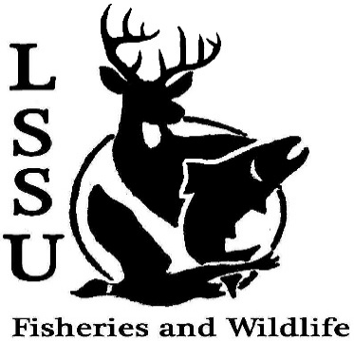
LSSU Fisheries and Wildlife Club
Meeting of January 20th, 2016
Called to Order @ 8:01

Officers
President: Cliff Pattinson: cpattinson@lssu.edu (269) 841-6472
VP: Michelle Kane
Secretary: Autumn Wiese
Treasurer: John Milan
Events Committee Co-Chairs: Chris Cortell, Matt Grieb, Jake Northius
Fundraising Committee Chairs: Alleigh Sexton, Elizabeth Cilman

- Officer’s Report
  - Vice President – Michelle Kane
  - Secretary – Autumn Wiese 1st by Cole, 2nd by Patrick
  - Treasurer – John Milan 1st by Michael, 2nd by Cole
  - Raffle Committee – Alleigh Sexton
- Old Business
  - Winter Break Photos, experiences, etc? Cliff shared story about his break
  - Marine Biology Belize Trip Reflections Moved to next meeting due to speaker cancellation
- New Business
  - Special Election for Incumbent Secretary
    - Announcement and Nominations tonight
    - Election next meeting
Katherine Skubik nominated by Mike, Accepts
Sara Ostwald nominated by Cole, Rejects
Anthony Saxman nominated by Jake, Rejects
Juliet Golob nominated by Mike, Accepted initially, Rejected by email on January 31st
Mary Markel nominated by Juliet, Accepted initially, Rejected January 24th
Emily Barcly nominated by Cole, Rejects
Chris Cortel nominated by Mike, Rejects
Nicholas Moorman nominated by Cliff, Rejects
  - Midwest Fish and Wildlife Conference, Grand Rapids, MI – January 24-27
    - Leave on Saturday (23rd) 3 pm, Library Parking Lot meet at 2:30 pm
  - Upcoming Events after Midwest (All dates TBA if not noted)…
    - Bird ID Workshop – Jake Northuis
    - Possible Falconry Mini-Workshop w/ Dr. Heth’s Sponsor
    - Resume Workshop– John Milan
    - Doug Reeves Retirement Get-Together(s) – Friday, Jan. 29th AND April 2nd
    - Bird Conference
    - TWS North Central Student Conclave – April 1-3, Tomahawk WI (Host: University of Wisconsin Stevens Point)
    - MI TWS Annual Meeting
    - Bowling outing?
    - Tubing outing?
    - Sampling trip with MSU
    - Other aquatic sampling opportunities with warmer weather
  - JOB OPPORTUNITIES – Watch your email!
    - USAJOBS Tutorial Logged in and showed them the site
  - Have an idea for an event? Talk to Events Committee or any of the Officers!
  - Have an idea for a Meet and Greet? Talk to Events committee or any of the Officers!
  - Senior Research help? No

- Reminders
  - Please take photos and videos at FWC events!
  - Pay your dues!
  - Like the Facebook page!
  - Visit our Website! http://www.lssufwc.weebly.com/

Next Meeting: February 3rd, 2016 @ 8 PM
Close at 8:38 pm, 1st by Graham, 2nd by Cole

