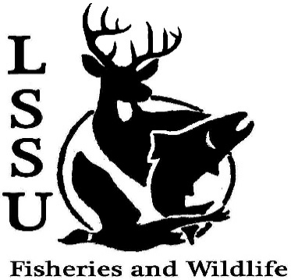
LSSU Fisheries and Wildlife Club

Meeting of February 5th, 2020

Start time:8:00

1st: Mike 2nd: Jake

Officers

President: Riley Waterman Rwaterman@lssu.edu (269) 806-0980
Vice President: Austin Heslinga
Secretary: Trenton Schipper
Treasurer: Michael Gray
Committee Chairs:
      - Events- Ben Short
      - Social Media-
      - Fundraising- Jasmin Estes
      - Apparel- Avery Feldmeier
- Officer’s Report
  - Vice President- Austin Heslinga It’s George’s Birthday
  - Secretary- Trenton Schipper
  - Treasurer – Michael Gray Treasurer Michael couldn’t make it
- Old Business
  - Midwest Fisheries and Wildlife Conference Evan gave a word
- New Business
  - CFRE Work and Volunteer Opportunities Molly and Connor gave a word
  - Meet and Greet with Sam Griffin: Huron Pines Americorps- Feb 11th 7 p.m.
  - Meet and Greet with USFS (Hiawatha National Forest)- Feb 19th 11:30-12:30, (pizza hour)
  - MI AFS Annual Meeting- March 11-13th, Mount Pleasant, MI (CMU)
  - MITWS March 18th-20th, Bellaire- (Head Counts)
  - Think about committee chairs
  - Think about event ideas for this year
  - Raffle prizes for whitefish dinner (tax write-off form on website)
  - Send pictures of past events to officers
  - Senior Research help?
  - Have an idea for a speaker or a Meet and Greet at Laker Hall? Talk to Events committee or any of the officers!
  - Check your email for notifications!

- Reminders
  - Please take photos and videos at FWC events!
  - Pay your dues!
  - Like the Facebook page!
  - Follow us on Instagram @lssufwc
  - Visit our Website! http://www.lssufwc.weebly.com/

Next Meeting: February 19th

End Time: 8:19

1st:Evan 2nd:Avery/Jake

