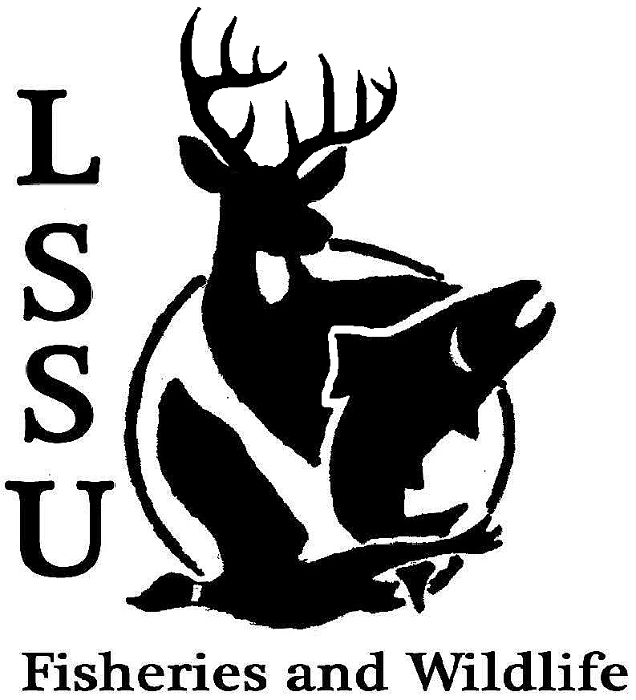
LSSU Fisheries and Wildlife Club
Meeting of January 14th, 2015
Kyle Hafeman: khafeman@lssu.edu (906) 295-1585

Meeting called to order at 8:01 pm

- Officers Report
  - Secretary – Addie Dutton Addie presented the minutes from the previous meeting. Nate motioned for approval, second by Jake. Minutes were approved by the club.
  - Treasurer – Jake Truitt Jake presented the treasurer report from the previous meeting. Logan motioned for approval, second by Garret. The report was approved by the club.
  - Event Committee – Maddy and Gislaine
    - Tracks and Telemetry Workshop-Jan. 31st, 2pm
    - Krista Ryall (Ash Borer) – Jan. 28th, 7pm CRW 205
    - Pedro Antunes (Invasive Plants) – Feb. 11th, 7pm CRW 205
    - MI Bird Conservation Workshop
      - March 19-21, Tustin, MI
Maddy and Gessie presented on all of these events. The tracks and telemetry workshop will be put on by them and any upperclassmen that would like to help out please contact them. Guest speakers will be coming please attend.
Addie will send out the URC grant to anyone interested in applying to receive funding for their project through the university…they are due Feb. 2nd
  - Raffle Committee – Cliff
    - Raffle Donations
    - Raffle Blitz Cliff would like help setting up tables at MIAFS and writing the forms for the silent auction. Anyone that is going to conference please help Cliff out. If you have any last minute raffle prizes, please get them to Cliff immediately!
- New Business
  - MI AFS Meeting – Leaving Time? Anyone that is planning on attending MIAFS please stay after the meeting so we can decide on all arrangements.
    - Possible travel arrangements
  - Midwest F&W Conference – Travel applications submitted asap
    - Feb. 8-11th, Registration is online, http://www.midwestfw.org/ We will be awarded the most active student subunit award at the meeting! Congrats to the officers of last year for making this a success. If you are going, please get your travel application into Dr. Moerke ASAP
  - Fly Fishing Film Tour – February 21st, 6pm Fine Arts Center Ticket prices will be $5 for students, $12 for adults, and $15 at the door. FWC members will help out with selling tickets and the raffle in between the break of the film (~1hour)
  - ARL Opening-Roger Greil The ARL is currently looking to fill a weekend position vacancy. This position is open until Friday night. Preference will be given to upperclassmen that have not had the opportunity to work. The schedule will consist of one weekend on and one weekend off.
  - Coaster Brook Trout Research-Dr. Kirkpatrick Dr. Kirkpatrick forwarded me (ADDIE) an email regarding possible research grants for students interested in studying Coaster Brook Trout in Lake Superior. Please let me know if you would like me to forward the information to you and pass your names along to Dr. Kirkpatrick.
  - Senior Research help?
- Reminders
  - Please take photos at FWC events!
  - Pay your dues!
Next Meeting: Wednesday January 28th @ 8 PM
Meeting adjourned motion to adjourn first by Logan and second by Jacob at 8:18pm

