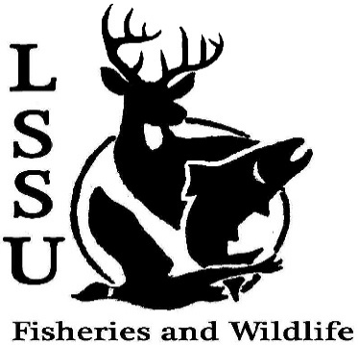
LSSU Fisheries and Wildlife Club

Meeting of September 19th, 2018
Start time: 8:00
1st: Mike 2nd: Shaun

Officers

President: Conner Johnson cjohnson30@lssu.edu (641)-919-0723
Vice President: Benjamin Larrabee
Secretary: Kaitlyn Yantz
Treasurer: Britney Weaver
Committee Chairs:
      - Events-Patrick James, Evan Farrier
      - Apparel- Douglas Kreutzkamp
- Officer’s Report
  - Vice President – Benjamin Larrabee
  - Secretary- Kaitlyn Yantz
  - Treasurer – Britney Weaver
- Old Business
  - Apparel Ideas
    - Hoodies or ¼ Zips not or but both
  - T-Shirt Drawing
    - Krystal Smith
  - Bio Bash Walking tacos, smelt and football

- New Business
  - Summer Facebook Competition
    - Fishing Competition Free dues if you win big fish, a t-shirt if you win little fish
    - No Filter Cellphone Competition
  - Elk Viewing Trip with Kelly Sept. 21st-23rd
  - Whitefish Dinner Oct. 27th
    - Raffle Prizes
  - Youth in the Outdoors in Seney Oct. 13th
  - Pine Pulling and Pond Sampling with Dr. Allen
    - Oct. 6-7 or Oct. 13-14 Yak burgers= yummy
  - Atlantic Salmon Netting at the ARL
    - TBA
  - Michigan Fish and Wildlife Conference March 13-15
    - Abstracts due September 30th
  - Senior Research help? Hadley always needs help this Friday
  - Have an idea for a speaker or a Meet and Greet at Laker Hall? Talk to Events committee or any of the officers!
  - Check your email for notifications!

- Reminders
  - Please take photos and videos at FWC events!
  - Pay your dues!
  - Like the Facebook page!
  - Visit our Website! http://www.lssufwc.weebly.com/

Next Meeting: October 3, 2018

End : 8:08

1st Benny 2nd Evan

