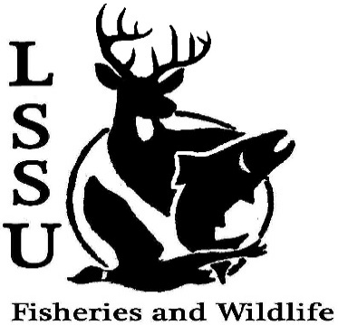
LSSU Fisheries and Wildlife Club
Meeting of September 7th, 2016
Called to Order at 8:13 1st by Cole 2nd by Patrick
Officers
President: Elizabeth Cilman ecilman@lssu.edu (989) 305-8599
Vice President: Juliet Golob
Secretary: Kelly Mildebrandt
Treasurer: Katherine Skubik

- Officer’s Report
  - Vice President – Juliet Golob
  - Secretary- Kelly Mildebrandt moved by Mike, 1st Cole, 2nd Mary
  - Treasurer – Katherine Skubik

- Old Business
  - Summer Experiences?
  - Salmon Derby Getting 10% of funds
- New Business
  - Club Dues
  - Emails
  - Bylaws and travel application Explained by Juliet
  - Committees- Chairs
    - Fundraising Explained by Cliff
    - Events
    - Apparel
  - Midwest Fish and Wildlife Conference (Lincoln, NE) - Abstracts due September 9th
  - LTBB Sturgeon release ( Wolverine township park, Sturgeon river)- September 8th at 5:30
  - LRBOI Sturgeon Release(Rainbow Bend Manistee, MI) - September 17th at 10:00
  - Elk Viewing and Camping Trip (Vanderbilt, MI)- September 16th-18th Explained by Kelly
  - Biogames- September 23rd at 2pm
  - Pine Pulling with Dr. Allen-date to be announced
  - Pond Sampling-Date to be announced
  - Owl Banding- date to be announced (October) 21st or 22nd
  - Whitefish Dinner Fundraiser -November 12th
    - Need volunteers
    - Need silent auction items
  - Summer Fishing Contest- ending September 20th
  - T-Shirt Drawing
  - Have an idea for an event? Talk to Events Committee or any of the Officers!
  - Have an idea for a speaker or a Meet and Greet at Laker Hall? Talk to Events committee or any of the officers!
  - Senior Research help?

- Reminders
  - Please take photos and videos at FWC events!
  - Pay your dues!
  - Like the Facebook page!
  - Visit our Website! http://www.lssufwc.weebly.com/

Next Meeting: September 21st, 2016
Meeting Closed at 8:48pm
1st Cole
2nd Patrick

