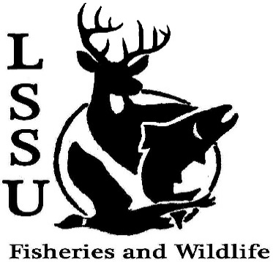
LSSU Fisheries and Wildlife Club

Meeting of March 20th, 2019

Start:8:02pm

Special Presentation from Serena Lake

Officers

President: Conner Johnson cjohnson30@lssu.edu (641)-919-0723
Vice President: Evan Farrier
Secretary: Kaitlyn Yantz
Treasurer: Britney Weaver
Committee Chairs:
      - Events- Patrick James
      - Social Media- Evan Farrier
      - Fundraising- Shaun O’Connor
      - Apparel- Douglas Kreutzkamp
- Officer’s Report
  - Vice President- Evan Farrier
  - Secretary- Kaitlyn Yantz
  - Treasurer – Britney Weaver 1st Evan 2nd Ethan
- Old Business
  - New Officer Elections
  - Michigan Fish and Wildlife Conference
    - Make sure to go next year!
- New Business
  - FWC Member of the Year Zack Walters
  - New Officer Inductions
  - Frog Workshop March 28th Evan
  - Tracking Workshop April 3rd Patrick
  - Summer orientations
  - Think about event ideas for next year
  - Raffle prizes for next year (tax write-off on website)
  - Senior Research help?
  - Have an idea for a speaker or a Meet and Greet at Laker Hall? Talk to Events committee or any of the officers!
  - Check your email for notifications!

- Reminders
  - Please take photos and videos at FWC events!
  - Pay your dues!
  - Like the Facebook page!
  - Follow us on Instagram @lssufwc
  - Visit our Website! http://www.lssufwc.weebly.com/

Next Meeting: April 3, 2019

End time: 8:28

1st Ethan 2nd Shaun

