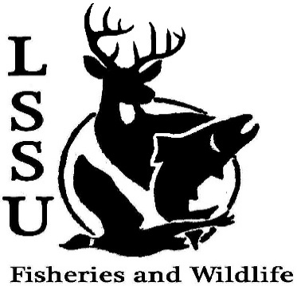
LSSU Fisheries and Wildlife Club
Meeting of February 1st, 2017
Called to order @ 8pm
Officers
President: Elizabeth Cilman ecilman@lssu.edu (989) 305-8599
Vice President: Juliet Golob
Secretary: Kelly Mildebrandt
Treasurer: Katherine Skubik
Committee Chairs:
      - Fundraising- Cliff Pattinson
      - Events-Riley Waterman
      - Apparel- Juliet Golob

- Officer’s Report
  - Vice President – Juliet Golob
  - Secretary- Kelly Mildebrandt Motion for Nov. 30th minutes by Patrick, 1st by Grace 2nd by John. Motion for Jan. 18th minutes by Twan, 1st by Patrick 2nd by Nick
  - Treasurer – Katherine Skubik Motion by Maddie, 1st by Patrick 2nd by Ethan
- Old Business
  - Telemetry Slide show presented by Riley. People had fun. Assembled the receiver. Found the collar
- New Business
  - WE NEED RAFFLE ITEMS! We have little if nothing. Preferredto have them before March 14th Can make them or buy them. Talk to Sara or Cliff about Businesses
  - Resume Workshop- Reschedule? Was canceled for power outage. Reschedule or wait for university event? Have more interest in rescheduling due to the unique resumes needed for F&W. Wed. 7-9? More details to come
  - Midwest- February 5th-8th Wish people good luck and safe travels
  - Michigan AFS Conference- Tuesday-Thursday, March 14th-16th in Mackinaw City ( Mackinaw Beach and Bay Inn and Suites)
    - Abstracts- due February 17th One more reminder at the next meeting
    - Early Registration Fee- due March 3rd, $50 for students Are there posters as well as presentations?
    - More detail can be found at: http://michigan.fisheries.org/annual-meeting/upcoming-meeting/
  - TWS Annual Meeting- March 16th-17th Location TBA Still no location
  - Relay For Life- March 25th 11am-11pm
    - http://main.acsevents.org/site/TR/?fr_id=81487&pg=team&team_id=2157176 Official team sign up. No charge. Held in the SAC
  - TWS North Central Student Conclave- March 24th-26th
    - Early Registration $80 before February 18th Register quick!
    - Camp Tecumseh: Brookston, Indiana
    - Details and registration packet found at: http://wildlife.org/next-generation/annual-conclaves/ FWC will pay for travel, keep officers updated if you're planning on attending
  - Snowy Owl Trip- Date TBA No info yet
  - New Officer Nominations Next Meeting- February 15th
Treasurer→ buy snacks, excel sheet for calculations, in charge of keeping track of expenses and revenue.
VP→ pick up extra stuff as needed. Update the website. Took up apparel personally, not the assigned job of the VP
President→ run meetings, make the agenda, fill out applications the club needs, contact important people and attend president's council
Secretary→ Take minutes for officer and club meetings, send emails and club reminders
Think about who you want as an officer
  - Have an idea for an event? Talk to Events Committee or any of the Officers!
  - Have an idea for a speaker or a Meet and Greet at Laker Hall? Talk to Events committee or any of the officers!
  - Senior Research help?
Cliff→ Still have spots open, start feeding trials next week
Chris→ electroshocking, boomshock, talk to Chris for contact
- Reminders
  - Please take photos and videos at FWC events! Thanks for the slide shows
  - Pay your dues!
  - Like the Facebook page!
  - Visit our Website! http://www.lssufwc.weebly.com/

Next Meeting: February 15th, 2017
Closed @ 8:20 pm
1st by Chris, 2nd by Nick

