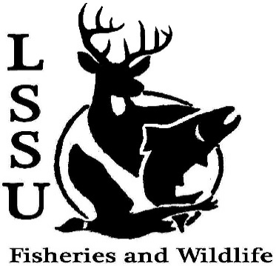
LSSU Fisheries and Wildlife Club

Meeting of November 7th, 2018

1st patty 2nd ethan

Officers

President: Conner Johnson cjohnson30@lssu.edu (641)-919-0723
Vice President: Benjamin Larrabee
Secretary: Kaitlyn Yantz
Treasurer: Britney Weaver
Committee Chairs:
      - Events- Patrick James
      - Social Media- Evan Farrier
      - Fundraising- Shaun O’Connor
      - Apparel- Douglas Kreutzkamp
- Officer’s Report
  - Vice President – Benjamin Larrabee
  - Secretary- Kaitlyn Yantz
  - Treasurer – Britney Weaver
- Old Business
  - Whitefish Dinner Oct 27th Great turn out!
    - Thank you for helping!
  - Atlantic Salmon Netting Oct 31st and Nov. 1st Went very successfully!
  - Kids Kollege Nov. 3rd Fun trying to teach kids about aquatic insects and animal tracks and dissecting cats
  - New Apparel
    - Hoodies
    - ¼ Zips
    - T-Shirts
- New Business
  - Midwest Fish and Wildlife Conference
    - January 27-30th
    - Cleveland, Ohio
  - Electroshocking and Fish ID Workshop Nov. 9 Great experience
    - Contact Riley Waterman
  - Egg Take at ARL Nov. 8th at 8am
  - CFRE Needs a Logo
    - Winning design gets CFRE apparel
  - Senior Research help? Hadley could use lab help
  - Have an idea for a speaker or a Meet and Greet at Laker Hall? Talk to Events committee or any of the officers!
  - Check your email for notifications!

- Reminders
  - Please take photos and videos at FWC events!
  - Pay your dues!
  - Like the Facebook page!
  - Follow us on Instagram @lssufwc
  - Visit our Website! http://www.lssufwc.weebly.com/

Next Meeting: November 14, 2018

End 8:09

1st Ethan 2nd Patty

