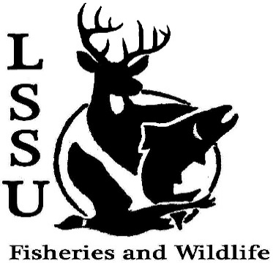
LSSU Fisheries and Wildlife Club
Meeting of November 2nd, 2016
Called to Order @8pm, 1st by Cole, 2nd by Mary
Officers
President: Elizabeth Cilman ecilman@lssu.edu (989) 305-8599
Vice President: Juliet Golob
Secretary: Kelly Mildebrandt
Treasurer: Katherine Skubik
Committee Chairs:
      - Fundraising- Cliff Pattinson
      - Events-Riley Waterman
      - Apparel- Juliet Golob

- Officer’s Report
  - Vice President – Juliet Golob
  - Secretary- Kelly Mildebrandt 1st by Cole, 2nd Patrick
  - Treasurer – Katherine Skubik 1st by Cole, 2nd Mary
- Old Business
  - Owl Banding Presented by Mike
  - Cisco Tagging Presented by Patrick and Sara
  - Birding Workshop Presented by Cole and Maddie
  - Atlantic Salmon Broodstock Netting Presented by Cliff and Sara
  - Fish Dissection and Insect ID Presented by Will and Maddie
- New Business
  - Meet and Greet with Steven Gambicki Biological Technician with USFWS for Alpena- Thursday November 3rd 7:00pm at laker hall
  - Laker Legion Box- with OAC and Fly Fishing Club November 4th
  - Meet and Greet with Emily Martin F&W Biologist for Bay Mills Indian Community- Wednesday November 9th 5:30pm at laker hall
  - Whitefish Dinner Fundraiser- November 12th
    - Tickets are available!
    - Don’t forget to ask faculty!
    - Two shifts 5:00pm-7:30 & 7:30-10:00
    - Need silent auction items- Due by 11-9-16
    - Contact any of the officers for more details
  - Have an idea for an event? Talk to Events Committee or any of the Officers!
  - Have an idea for a speaker or a Meet and Greet at Laker Hall? Talk to Events committee or any of the officers!
  - Senior Research help?
Cliff needs help with Cisco→ Has a Google calender for volunteers
- Reminders
  - Please take photos and videos at FWC events!
  - Pay your dues!
  - Like the Facebook page!
  - Visit our Website! http://www.lssufwc.weebly.com/

Next Meeting: November 16th, 2016
Meeting Closed @8:18pm
1st by Mary, 2nd by Patrick

