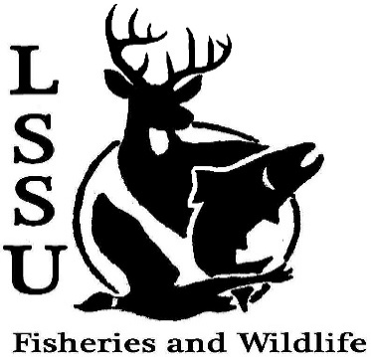
LSSU Fisheries and Wildlife Club
Meeting of October 21st, 2015
Started at 7:01pm
Officers
President: Cliff Pattinson: cpattinson@lssu.edu (269) 841-6472
VP: Michelle Kane
Secretary: Autumn Wiese
Treasurer: John Milan
Events Committee Co-Chairs: Chris Cortell & Matt Grieb
Fundraising Committee Chair: Alleigh Sexton

- Officer’s Report
  - Vice President – Michelle Kane
  - Secretary – Autumn Wiese First by Mike, Second by Anthony
  - Treasurer – John Milan First by Anthony, Second by Chris

- Old Business
  - Little Traverse Conservancy Clean Up of Round Island Point Conservancy

- New Business
  - Raffle Blitz: Oct. 23rd, 11 AM @ Library Parking Lot
  - Biogames – Oct. 24th, Laker Hall, Noon - need volunteers to help organize
  - Owl Banding Trip – Oct. 24th – contact Jake Northuis
  - Atlantic Salmon Brood-Stock Netting
    - Oct. 29th, 8:30 AM – Noon Thursday
    - Oct. 30th, 1 – 4 PM Friday
  - Cisco Tagging w/ Little Traverse Band of Odawa
    - Every day after 9 AM (done by Nov. 1st)
    - Just North of Pellston Airport
    - Contact Kris Dey
      - KDey@LTBBODAWA-NSN.GOV
      - (419) 460 – 5747
  - Whitefish dinner – Nov. 21st
    - TICKETS ARE AVAILABLE NOW
    - Workers needed, especially 2nd shift
    - Approve Whitefish amount of $674.25 First by Anthony, Second by Patrick
    - Vote on whitefish preparation
      - deep fried, pan fried, baked, broiled
22 26
    - Vote on potato preparation
      - Oven roasted or mashed
18 12
    - Need volunteers to help coordinate
      - 2 Shifts, Dinner for free if you work either shift
      - $15 prior to dinner
    - Need raffle items by 11-13-15
    - Contact Events Committee (Chris and Matt)
Garret talked about Predator Prey Project and the Opportunities possibly available
Contact Nick Fowler if interested, n.fowler@msstate.edu ; 660-229-3726
  - Midwest Fish and Wildlife Conference, Grand Rapids, MI – January 24-27
    - Sign-up and registration BEFORE Nov. 15
    - Scholarship available to freshman and sophomores for early registration costs only – submit letter to Dr. Moerke by October 28th stating why you are interested in attending the conference
    - Raffle?
  - Sampling Trip with MSU Update Next Semester TBA
  - Archery Club Carnival Idea, possible fundraising
  - Laker Legion Box – Oct. 30th?
  - Fish movement project – contact Dr. Moerke if you are interested in a day of sampling migratory fishes; help needed Tuesdays and Thursdays
  - AFS Video Contest and Photos
  - Senior Research help?

- Reminders
  - Please take photos at FWC events!
  - Pay your dues!
  - Like the Facebook page!
  - Visit our Website! http://www.lssufwc.weebly.com/

Next Meeting: November 4th, 2015 @ 7 PM
Ended at 7:44 pm First by Cole, Second by Anthony

