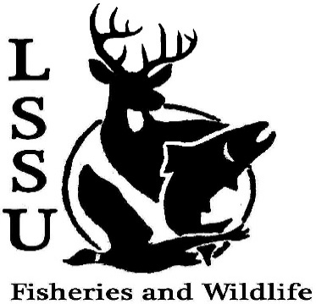
LSSU Fisheries and Wildlife Club

Meeting of October 18th, 2017 Start Time 8:02 pm

Officers

President: Will Marosi wmarosi@lssu.edu (313)-402-5261
Vice President: Riley Waterman
Secretary: Anna Bush
Treasurer: Cole VanOosten
Committee Chairs:
      - Fundraising- Nick Moorman
      - Events-Patrick James, Mary Markel
- Officer’s Report
  - Vice President – Riley Waterman None
  - Secretary- Anna Bush Last Weeks Minutes
  - Treasurer – Cole VanOosten Report-snacks, donations, white fish tickets sales 1st Mary 2nd Ethan
- Old Business
  - Dr. Allan’s Pond Sampling and Pine Pulling $100 coming, 1600 plus pines pulled, lots of fun and thanks
  - Meet and Greet fun, food, microplastics and professionalism
- New Business
  - Raffle Prizes Please keep them coming-due friday
  - Deer Shining- 4th Crew Members Needed on All Shifts Dates TBA Need a couple more people
  - Working Whitefish Dinner October 21st 4:00pm set up (Will has sign up sheet) meet at laker hall 4 pm, need help, free Dinner, sell tickets – due Friday
  - Aquatic Plant ID Workshop Dec 14th Gaylord Mi
  - R Workshop Jan 21st Traverse City, Mi
  - Midwest Fish and Wildlife Conference 28-31st Milwaukee, Wi
  - Meet and Greets: Oct 26th –Charles Dawley-GIS, Nov 2 – Brian Schmidt-Professionalism
  - Fly Fishing Club – meeting Thursdays at 8
  - Outdoor Adventure Club – Picture rocks 1st weekend in Nov.
  - Have an idea for a speaker or a Meet and Greet at Laker Hall? Talk to Events committee or any of the officers!
  - Senior Research help? Stewart – Owl Pelets (helping breaking them apart) talk to stewart or Juliet
  - Trail Building with Little travers... More info coming TBD talk to Dr. Moerke if you have questions
  - Need photos for slide show for White Fish Dinner
- Reminders
  - Please take photos and videos at FWC events!
  - Pay your dues!
  - Like the Facebook page!
  - Visit our Website! http://www.lssufwc.weebly.com/

Next Meeting: November 1st 2017

End Time 8:16 pm

1st Mary 2nd Ben

