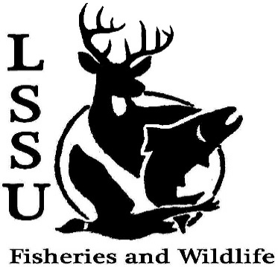
LSSU Fisheries and Wildlife Club

Meeting of October 17th, 2018
Start time: 8:00 1st shaun 2nd Doug

Officers

President: Conner Johnson cjohnson30@lssu.edu (641)-919-0723
Vice President: Benjamin Larrabee
Secretary: Kaitlyn Yantz
Treasurer: Britney Weaver 1st shaun 2nd patty
Committee Chairs:
      - Events- Patrick James
      - Social Media- Evan Farrier
      - Fundraising- Shaun O’Connor
      - Apparel- Douglas Kreutzkamp
- Officer’s Report
  - Vice President – Benjamin Larrabee
  - Secretary- Kaitlyn Yantz
  - Treasurer – Britney Weaver
- Old Business
  - Meet and Greet with Chris Vandergoot
  - Pine Pulling and Pond Sampling with Dr. Allan -Pulled about 2000 pine trees, pulled fyke net, yak burgers.
- New Business
  - Whitefish Dinner Oct. 27th
    - Tickets
    - Sign-up to Work -Sign up sheet went around
  - Raffle Blitzes with Shaun -Free Tuesdays and Thursdays to do this
  - Atlantic Salmon Netting at the ARL
    - Oct. 31st and November 1st
  - Kids Kollege Nov. 3rd -Workshop
    - Volunteers
  - Michigan Fish and Wildlife Conference March 13-15
    - Abstracts due October 31st
    - Technical Writing Workshop March 13th
  - Senior Research help? Hadley needs 2-3 people to help
  - Have an idea for a speaker or a Meet and Greet at Laker Hall? Talk to Events committee or any of the officers!
  - Check your email for notifications!

- Reminders
  - Please take photos and videos at FWC events!
  - Pay your dues!
  - Like the Facebook page!
  - Follow us on Instagram @lssufwc
  - Visit our Website! http://www.lssufwc.weebly.com/

Next Meeting: November 7, 2018

End: 8:15 1st benny 2nd patty

