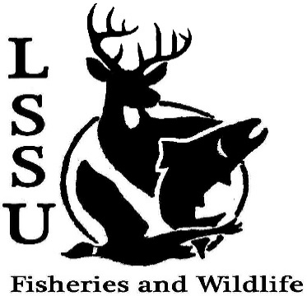
LSSU Fisheries and Wildlife Club

Meeting of October 4th, 2017

Open: 8:03 pm

Officers

President: Will Marosi wmarosi@lssu.edu (313)-402-5261
Vice President: Riley Waterman
Secretary: Anna Bush -
Treasurer: Cole VanOosten –
Committee Chairs:
      - Fundraising- Nick Moorman
      - Events-Patrick James, Mary Markel
- Officer’s Report
  - Vice President – Riley Waterman - None
  - Secretary- Anna Bush - Minutes
  - Treasurer – Cole VanOosten - Report (Dues and Snacks – BioBash)
1st Ethan 2nd Mike
- Old Business
  - Elk Viewing – Very Hot, called and saw some bull elk, lots of Fun
  - Raffle Blitzes – NEED More !!!!
  - Bio Bash – Fun! Good Food!
- New Business
  - Raffle Prizes – NEED Badly!! Need for club funding for trips and conferences
  - Deer Shining-Second Shifts Dates TBA – needed second shifts – need 2 more teams, Talk to Riley (one middle, one end, Oct. 15)
  - Dr. Allan Pond Sampling/Pine Pulling October 13th and 14th Yak Burgers, pine pulling, pond sampling, fyke net leave at 4 pm Friday, 9am Sat. (sharptail) - waders
  - Meet and Greet with Jeanie Williams on October 17th Inland Seas, 6-7 pm, Catering, at Laker Hall
  - Whitefish Dinner October 21st Need Helpers, Helping equals Free food, Talk to Juliet about selling tickets: 8 tickets = free t-shirt
  - R Workshop Jan 21st Traverse City, Mi
  - Midwest Fish and Wildlife Conference January 28-31st Milwaukee, Wi
  - Have an idea for a speaker or a Meet and Greet at Laker Hall? Talk to Events committee or any of the officers!
  - Senior Research help?
- Reminders
  - Please take photos and videos at FWC events!
  - Pay your dues!
  - Like the Facebook page!
  - Visit our Website! http://www.lssufwc.weebly.com/

Next Meeting: October 18th 2017

Close 8:15 pm

1st Mary 2nd Patrick

