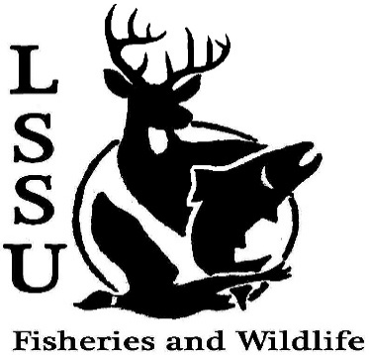
LSSU Fisheries and Wildlife Club

Meeting of October 3rd, 2018
Start time: 8:01pm Doug, Patty

Officers

President: Conner Johnson cjohnson30@lssu.edu (641)-919-0723
Vice President: Benjamin Larrabee Nothing to report
Secretary: Kaitlyn Yantz
Treasurer: Britney Weaver 8,334.11 checking 1st Ethan 2nd Kelly
Committee Chairs:
      - Events-Patrick James, Evan Farrier
      - Fundraising- Shaun O’Connor
      - Apparel- Douglas Kreutzkamp
- Officer’s Report
  - Vice President – Benjamin Larrabee
  - Secretary- Kaitlyn Yantz
  - Treasurer – Britney Weaver
- Old Business
  - Elk Viewing Trip Sept. 21st -23rd Kelly’s presentation: Bridge partial closure, seen 3x3, 5x5, 6x6, lots of cows. Sarah McNichols running it next year.
  - Summer Facebook Competition
    - Fishing Competition -Jason
    - No Filter Competition -George Shauffer

- New Business
  - Whitefish Dinner Oct. 27th Need volunteers to set up and cleaning
    - Raffle Prizes
  - Youth in the Outdoors in Seney Oct. 13th
  - Pine Pulling and Pond Sampling with Dr. Allen
    - Oct. 12-13
  - Raffle Blitzes with Shaun
    - Thurdays and Fridays
  - Atlantic Salmon Netting at the ARL
    - TBA Last week of October and next week of November
  - Michigan Fish and Wildlife Conference March 13-15
    - Abstracts due October 31st
  - Follow Our New Instagram Page!
    - lssufwc
  - Senior Research help?
    - Hadley Reed
      - 12:00-4:00 this weekend
      - hreed2@lssu.edu
  - Have an idea for a speaker or a Meet and Greet at Laker Hall? Talk to Events committee or any of the officers!
  - Check your email for notifications!

- Reminders
  - Please take photos and videos at FWC events!
  - Pay your dues!
  - Like the Facebook page!
  - Visit our Website! http://www.lssufwc.weebly.com/

Next Meeting: October 17, 2018

End time:8:35pm 1st Patty 2nd George

