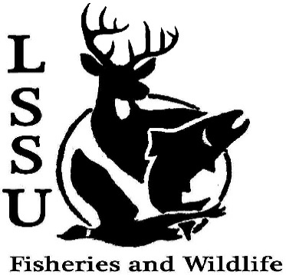
LSSU Fisheries and Wildlife Club

Meeting of April 17th, 2019

Start Time: 8:00

1st :Shaun 2nd: Ryan

Special Presentation from Cole VanOosten

Officers

President: Riley Waterman Rwaterman@lssu.edu (269) 806-0980
Vice President: Austin Heslinga
Secretary: Trenton Schipper
Treasurer: Michael Gray
Committee Chairs:
      - Events- TBD
      - Social Media- Evan Farrier
      - Fundraising- TBD
      - Apparel- TBD
- Officer’s Report
  - Vice President- Austin Heslinga
  - Secretary- Trenton Schipper Minutes 1st :Ethan 2nd :Evan
  - Treasurer – Michael Gray 1st : Shaun 2nd : Avery
- Old Business
  - Frog Workshop
  - Aquatic Insect ID Extravaganza
- New Business
  - Guest Speaker Cole VanOosten
  - CFRE Earth Day Challenge, April 13-22
(https://www.lssu.edu/cfre/2019-earth-day-challenge/menu-of-challenges/)
  - Spring Grouse Lekking Surveys on Drummond Island, Contact Evan Farrier
  - MIAFS Stream Habitat Assessment Workshop, June 4-5, Gaylord, MI
  - Tahquamenon Trip Saturday, April 20 meet @ Laker Hall 3pm, Carpool there
  - Invasive Species Technician- Bay Mills Biological Services
  - Think about committee chairs
  - Summer orientations- Need volunteers!
- Thur, June 20th
- Sat, June 22nd
- Mon, June 24th
- Thur, July 11th
- Fri, July 12th
- Mon, July 15th
  - Think about event ideas for next year
  - Raffle prizes for next year (tax write-off form on website)
  - Summer Facebook Competition
    - Fishing Competition
    - #NoFilter Cellphone Competition
  - Send pictures of past events to officers
  - Senior Research help?
  - Have an idea for a speaker or a Meet and Greet at Laker Hall? Talk to Events committee or any of the officers!
  - Check your email for notifications!

- Reminders
  - Please take photos and videos at FWC events!
  - Pay your dues!
  - Like the Facebook page!
  - Follow us on Instagram @lssufwc
  - Visit our Website! http://www.lssufwc.weebly.com/

Next Meeting: See you in the fall!

End Time: 8:53

1st : Evan 2nd : Zach

