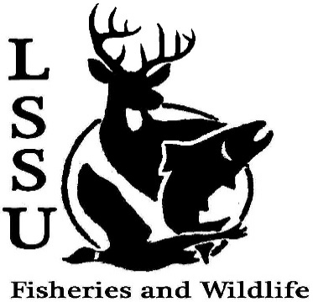
LSSU Fisheries and Wildlife Club

Meeting of January 30th, 2019

Start: 8:00 1st Mike 2nd Shaun

Officers

President: Conner Johnson cjohnson30@lssu.edu (641)-919-0723
Vice President: Evan Farrier
Secretary: Kaitlyn Yantz
Treasurer: Britney Weaver
Committee Chairs:
      - Events- Patrick James
      - Social Media- Evan Farrier
      - Fundraising- Shaun O’Connor
      - Apparel- Douglas Kreutzkamp
- Officer’s Report
  - Vice President- Evan Farrier
  - Secretary- Kaitlyn Yantz
  - Treasurer – Britney Weaver 1st Austin 2nd Patty
- Old Business
  - Temporary Vice President Elections
    - Congratulations, Evan
  - Snowy Owl Viewing Trip
  - Event Brainstorming
- New Business
  - Resume and Cover Letter Workshop
    - Limit of 15 people
    - Feb. 5th
    - 5:00pm @ Hillside
    - Bring a Copy of Resume and Job Posting
  - Midwest F&W Hotel Costs Approval
    - $1053.30 Approved by all
  - Chili Cook-Off
    - Feb. 18th
  - Tubing Trip
    - Evening of Feb. 9th
  - CFRE Snowshoeing Trip
    - February 9th
    - Talk After Meeting
  - Movie Nights
    - What Should We Watch? The great outdoors
  - Hat Contest
    - Submit Designs by Next Meeting
  - Midwest Fish and Wildlife Conference January 27-30th
  - MI Fish and Wildlife Conference March 13-15th
    - Treetops Resort in Gaylord, MI
    - Registration Open
    - Great Opportunity for Everyone!
  - New Officer Nominations Next Meeting
  - Senior Research help?
  - Have an idea for a speaker or a Meet and Greet at Laker Hall? Talk to Events committee or any of the officers!
  - Check your email for notifications!

- Reminders
  - Please take photos and videos at FWC events!
  - Pay your dues!
  - Like the Facebook page!
  - Follow us on Instagram @lssufwc
  - Visit our Website! http://www.lssufwc.weebly.com/

Next Meeting: February 13, 2019

End time: 8:23pm

