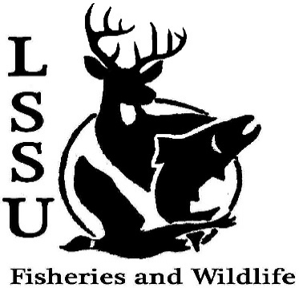
LSSU Fisheries and Wildlife Club

Meeting of April 3rd, 2019

Meeting Start: 8:00

1st:Shaun 2nd:Avery

Officers

President: Riley Waterman Rwaterman@lssu.edu (269) 806-0980
Vice President: Austin Heslinga
Secretary: Trenton Schipper
Treasurer: Michael Gray
Committee Chairs:
      - Events- Patrick James
      - Social Media- Evan Farrier
      - Fundraising- Shaun O’Connor
      - Apparel- Douglas Kreutzkamp
- Officer’s Report
  - Vice President- Austin Heslinga
  - Secretary- Trenton Schipper
  - Treasurer – Michael Gray 1st: Connor 2nd: Ethan
- Old Business
  - Officer swear-ins
- New Business
  - Frog Workshop April 4th @ 6:00-8:00, CRW 209 Evan spoke a word about the workshop
  - Aquatic Insect ID extravaganza April 16th @ 5:00-7:00, CRW 257 Evan spoke a word about the extravaganza.
  - Think about committee chairs
  - Summer orientations- Need volunteers!
- Thur, June 20th
- Sat, June 22nd
- Mon, June 24th
- Thur, July 11th
- Fri, July 12th
- Mon, July 15th
  - Think about event ideas for next year
  - Raffle prizes for next year (tax write-off form on website)
  - Summer Facebook Competition
    - Fishing Competition
    - #NoFilter Cellphone Competition
  - Send pictures of past events to officers
  - Senior Research help?
  - Have an idea for a speaker or a Meet and Greet at Laker Hall? Talk to Events committee or any of the officers!
  - Check your email for notifications!

- Reminders
  - Please take photos and videos at FWC events!
  - Pay your dues!
  - Like the Facebook page!
  - Follow us on Instagram @lssufwc
  - Visit our Website! http://www.lssufwc.weebly.com/

Next Meeting: April 17, 2019

End Time: 8:10

1st:Ryan 2nd: Ben

