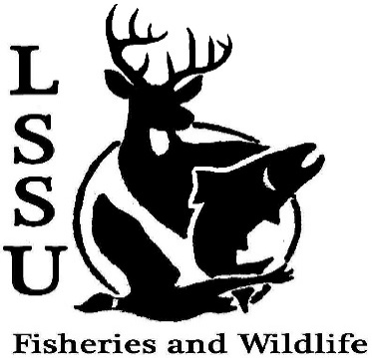
LSSU Fisheries and Wildlife Club
Meeting of March 23rd, 2016
Called to Order at 20:00

Officers
President: Cliff Pattinson: cpattinson@lssu.edu (269) 841-6472
VP: Michelle Kane
Secretary: Jake Northuis (incumbent)
Treasurer: John Milan
Events Committee Co-Chairs: Chris Cortell, Matt Grieb Fundraising Committee Chairs: Alleigh Sexton, Elizabeth Cilman

- Officer’s Report
  - Vice President – Michelle Kane
  - Secretary, Incumbent – Jake Northuis 1st Anthony 2nd Graham
  - Treasurer – John Milan 1st Chris 2nd Patrick
- Old Business
  - Dissections at JKL School w/ Ms. Purple
  - F3T
  - DU Banquet
- New Business
  - 2016-2017 Officer ELECTIONS TONIGHT!!
    - President
      - Mike Oertel
      - Elizabeth Cilman – Winner!
      - Katherine Skubik
    - Vice President
      - Ethan Thomas
      - Juliet Golob – Winner!
      - Elizabeth Cilman
      - Matt Grieb
      - Cole VanOosten
    - Treasurer
      - Cole VanOosten
      - Juliet Golob
      - Katherine Skubik- Winner!
    - Secretary
      - Kelly Mildebrandt- Winner!
      - Katherine Skubik
      - Juliet Golob
      - Elizabeth Cilman
  - UP Chapter (ice fishing) outing w/ NMU – (tentative) April 10th
  - MI DNR Public Fishing Regulation Meeting – March 31st, Anchor Room, Cisler Center, 6 – 8 pm
    - Meet and Greet to follow at Laker Hall (approx. 8 pm)
  - TWS North Central Student Conclave – April 1-3, Tomahawk WI (Host: University of Wisconsin Stevens Point)
  - Resume Workshop – John Milan, in works
  - Fish ID AND Sampling Workshop – in the works
    - Warmer weather = more sampling opportunities!
  - Fish Movement Project back underway March 15th – Contact Eddie Barta rbarta1@lssu.edu if interested
  - Hunt Creek Internships available w/ possible Workshop in May
  - Little Traverse Bay Band of Odawa internships available – possible housing and pay included! If interested email Dr. Moerke and Dr. Kapuscinski with resume by March 27th.
  - Many internships / job postings available! Watch your email!
  - Have an idea for an event? Talk to Events Committee or any of the Officers!
  - Have an idea for a Meet and Greet? Talk to Events committee or any of the Officers!
  - Senior Research help?

- Reminders
  - Please take photos and videos at FWC events!
  - Pay your dues!
  - Like the Facebook page!
  - Visit our Website! http://www.lssufwc.weebly.com/

Next Meeting: April 6th, 2016 @ 8 PM
Called to Close 20:38
1st Ben
2nd Patrick

