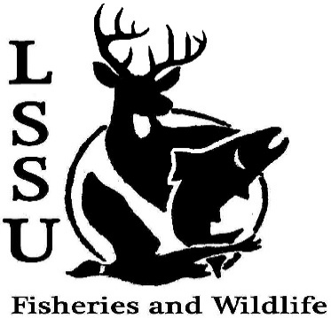
LSSU Fisheries and Wildlife Club

Meeting of November 29th, 2017

Officers

President: Will Marosi wmarosi@lssu.edu (313)-402-5261
Vice President: Riley Waterman
Secretary: Anna Bush
Treasurer: Cole VanOosten
Committee Chairs:
      - Fundraising- Nick Moorman
      - Events-Patrick James, Mary Markel
- Officer’s Report
  - Vice President – Riley Waterman
  - Secretary- Anna Bush
  - Treasurer – Cole VanOosten
- Old Business
  - Meet and Greet with Brian Schmidt
  - Trail Management- Cancelled due to weather
  - Atlantic salmon brood stock netting and egg take
- New Business
  - Plant/Fish/Wildlife Workshops- Next Semester
  - R Workshop Jan 21st Traverse City, Mi
  - Aquatic Plant ID Workshop Dec 14th Gaylord Mi
    - Few “free” student spots still available
    - If attending speak with Will or Cole
  - Midwest Fish and Wildlife Conference 28-31st Milwaukee, Wi
    - Early registration deadline Dec 15th
    - If attending speak with Will or Cole
  - Event ideas for next semester
  - GOOD LUCK ON FINALS
  - Have an idea for a speaker or a Meet and Greet at Laker Hall? Talk to Events committee or any of the officers!
  - Senior Research help?
- Reminders
  - Please take photos and videos at FWC events!
  - Pay your dues!
  - Like the Facebook page!
  - Visit our Website! http://www.lssufwc.weebly.com/

Next Meeting: Next Semester TBA

