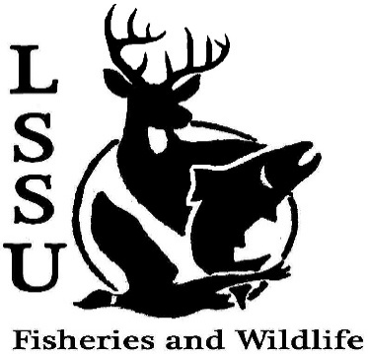
LSSU Fisheries and Wildlife Club
Meeting of March 9th, 2016

Officers
President: Cliff Pattinson: cpattinson@lssu.edu (269) 841-6472
VP: Michelle Kane
Secretary: Jake Northuis (incumbent)
Treasurer: John Milan
Events Committee Co-Chairs: Chris Cortell, Matt Grieb Fundraising Committee Chairs: Alleigh Sexton, Elizabeth Cilman

- Officer’s Report
  - Vice President – Michelle Kane
  - Secretary, Incumbent – Jake Northuis
  - Treasurer – John Milan
- Old Business
  - Bird ID -Dani and Kelly Win
  - Chili Cook Off - Jess Wesolek Was the most eaten
  - Science Spring Break Trip
  - Spring Break experiences?
- New Business

  - Officer nominations TONIGHT – Election NEXT MEETING
    - Secretary
    - Treasurer
    - Vice President
    - President
  - UP Chapter (ice fishing) outing w/ NMU – Sunday, March 13th –pushed back with no rush for safe ice
  - Fish Dissections with Ms. Purple’s Class – March 15th, two sections
    - Section 1 – 10:10 AM
    - Section 2 – 1:00 PM
  - Fly Fishing Film Tour – March 19th, Art Center
    - Volunteers for FWC Table, helping Fly Fishing Club with security
    - Free admittance for volunteers helping watch tables
    - Tickets available: $5 admittance for students, $15 general admittance
    - Silent Auction items requested
    - Contact Matt Grieb with questions or concerns
  - MI DNR Public Fishing Regulation Meeting – March 31st, Anchor Room, Cisler Center, 6 – 8 pm
    - Meet and Greet to follow at Laker Hall (approx. 8 pm)
  - TWS North Central Student Conclave – April 1-3, Tomahawk WI (Host: University of Wisconsin Stevens Point)
  - Fish ID Workshop – in the works
    - Warmer weather = more sampling opportunities!
  - Fish Movement Project back underway March 15th – Contact Eddie Barta rbarta1@lssu.edu if interested -Email sent out for involvement interest
  - Hunt Creek Internships available w/ possible Workshop in May
  - Little Traverse Bay Band of Odawa internships available – possible housing and pay included! If interested email Dr. Moerke and Dr. Kapuscinski with resume by March 27th.

  - Many internships / job postings available! Watch your email! -Jakehas been flooding your emails
  - Have an idea for an event? Talk to Events Committee or any of the Officers!
  - Have an idea for a Meet and Greet? Talk to Events committee or any of the Officers!
  - Senior Research help?

- Reminders
  - Please take photos and videos at FWC events!
  - Pay your dues!
  - Like the Facebook page!
  - Visit our Website! http://www.lssufwc.weebly.com/

Next Meeting: March 23rd, 2016 @ 8 PM

