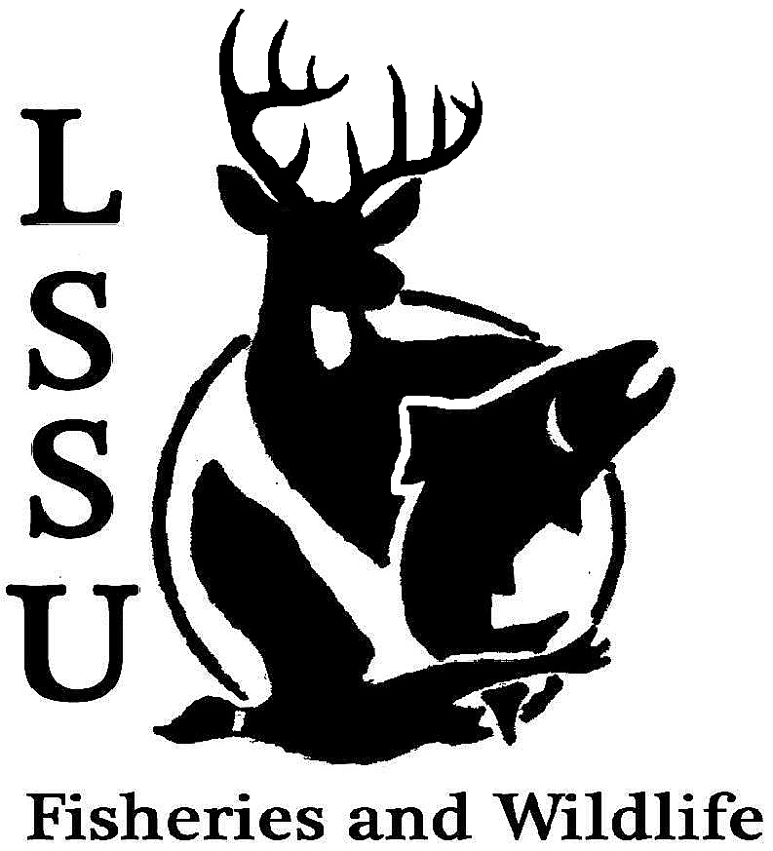
LSSU Fisheries and Wildlife Club
Meeting of December 3rd, 2014
Kyle Hafeman: khafeman@lssu.edu (906) 295-1585

Meeting called to order at 8:01 pm by Kyle

Paul from the ROC talked with the club about possible joint events and ice fishing products that he should purchase for student use from the ROC

- Officers Report
  - Vice President – Jayne Meinhard Nothing to report
  - Secretary – Addie Dutton Reported the minutes from the last club meeting. Motion for approval first by Eddie and second by Coleson. Minutes were approved.
  - Treasurer – Jake Truitt Jake presented the treasurer minutes. $10 in dues were collected and the checking now has $4,504 in it. Motion for approval first by Logan and second by Luke. Minutes were approved.
  - Event Committee – Maddy and Gislaine
    - Atlantic Salmon Egg Take No fish tested negative for BKD and it was a fun time “making babies”
    - ARL Newsletters Meghan, James, and Cliff attended and they folded and tabbed a lot of newsletters and Dr. Roese brought pizza
    - MI Bird Conservation Workshop
      - March 19-21, Tustin, MI Last year it was $25 for registration and it was a fun time. Your research can be ongoing that you present it does not have to be finished. James was one of the students who attended last year and he enjoyed it.
      - Call for proposals due Jan. 9th
      - Additional ideas for the spring semester for events included Tubing on Tuesdays and Bowling on Sundays when the prices are reduced
  - Raffle Committee – Cliff
    - Raffle Donations Silent Auction and Raffle at MIAFS but before we have only had a raffle. Raffle license should be here and while you are home on break try and hit up any local businesses about getting donations for the raffle in support of our club
    - Thank You Cards All cards have been finished and will be sent out on Friday. Thank you for everyone that came and helped write them.

- New Business
  - Midwest F&W Conferences-Registration now open, early deadline Dec. 19th
    - Feb. 8-11th, Registration is online, http://www.midwestfw.org/
  - MI AFS – Registration open for Midwest, early deadline Jan. 9th
    - Jan 19-21st , Registration is online, http://www.fisheriessociety.org/miafs/upcoming_meet.html
    - If you are planning on attending either of these conferences sign up, however if you are not going to actually go do NOT sign up. We need to know the actual number of people who are attending these conferences to make travel arrangements. Also if you are planning on attending, you need to turn in your travel grant to Dr. Moerke
  - Placing an order for baseball caps We are planning on placing an order through Cabelas to order 50 baseball hats in navy and forest green with the LSSU FWC logo on the front of them
  - Resume Seminar-Monday Dec. 8th , Laker Hall 4:30PM
    - Email Dr. Moerke to sign up and bring resume If you want to attend, please email Dr. Moerke in advance and do not be late. Dr. Roese will also be present to help students with their resumes.
  - James Miller Hunting Charity James Miller a FW graduate from last year has a nonprofit charity set up DOEnations and would like to know if anyone in the FWC is interested in helping him out. They need hunters who will legal harvest deer and donate the meat to local food pantries or to allow hunters to take deer off of their land to give to local food banks. Contact Addie for more information and how to get into contact with James.
  - MIAFS Student Video Contest – Entries due December 31st We showed the video for MSU’s F&W program and it is great. It makes all of us want to attend MSU. If you have pictures and you can add them together with sounds or animation enter your video into the contest. There is a $100 prize for the winner!
  - MSU Extension Course – March 2nd and 3rd email Kyle for information
  - Senior Research Help? Garret is still in need of mink and if you have any way or any contact information for anyone that traps mink please let him know.
  - F3T-LSSU FWC Help? Addie and Kyle attended the first meeting for planning for the Fly Fishing Film Tour. We would benefit through this by receiving half of the profits. We would be in charge of helping sell tickets and putting up flyers around campus before the event. During the event, we will be collecting tickets and ushering people to seats if needed. Motion for club to become a part of this event first by Coleson and second by Logan. Club approved becoming a part of the F3T at LSSU.
- Reminders
  - Please take photos at FWC events!
  - Pay your dues!
Next Meeting: Wednesday January 14th @ 8 PM
Motion to end the meeting first by Coleson and second by Jayne.

