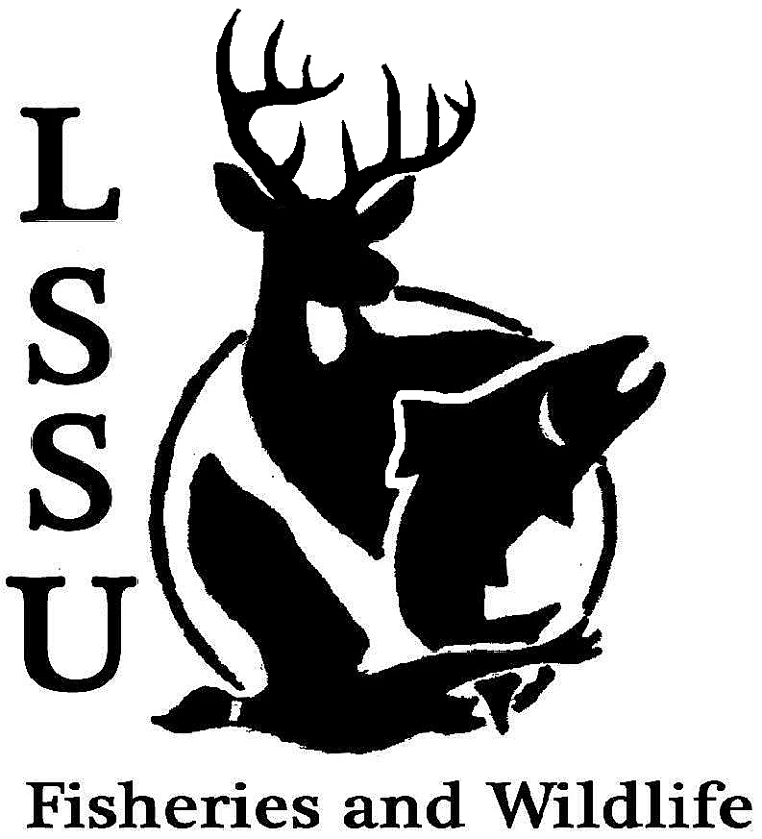
LSSU Fisheries and Wildlife Club
Meeting of September 17th, 2014
Kyle Hafeman: khafeman@lssu.edu (906) 295-1585

- Officers Report
  - Treasurer – Jake Truitt Jake presented the treasure’s report showing the expenses from snacks bought for this meeting and last meeting as well as money made from dues and apparel sales. Approved: First by Logan and Second by Nate.
  - Committee Report: Events Committee Gessie and Maddy presented the events committee report about how the sturgeon release was a great time and they networked with numerous professionals in the field. They also covered Dr. Allan’s Pond Sampling and BioGames that will be happening in the upcoming weeks before the next meeting. They also discussed the turn out for the fisheries workshop and how much fun it was and showed pictures from both the sturgeon release and fisheries workshop. They covered all of the old business section.

- Old Business Covered by Events Committee as noted above
  - Fisheries Workshop
  - Sturgeon Release with LRBOI
  - Facebook Group

- New Business
  - Facebook Fishing Tournament Showed a powerpoint slide show with all of the entries over the summer and then took a vote as each picture was numbered, all officers were included as honorable mentions but were not allowed to be part of the contest. Drake a freshmen was the big winner with a huge Muskie!!
  - Biogames- Rescheduled for September 28th Covered in the beginning of the meeting by Events Committee
  - Committee Needs – Raffle! Cliff Pattinson expressed interest in this position and we thank him greatly!!
  - Club Website – Update and Maintain Chuck Norris is the new club website man, and we appreciate this greatly
  - Raber Bay frog-bit removal- Sept. 19th and 20th
    - Contact Jayne Meinhard Car pooling will meet in the Library parking lot both days at 8am, come prepared with waders, a lunch and bring a kayak or boat if you have access to one. Jake offered to let anyone borrow his kayak if they were interested.
  - Dr. Allan’s Pond Sampling – Sept. 27th and 28th Also covered by Events Committee leaving from the library parking lot at 8am each morning again.
  - Fall Fling – Sept. 28th, 11-2 This was mentioned to see if anyone would be interested or available to work the FWC booth at Fall Fling to encourage prospective students of LSSU and then of the FWC.
  - Parent Societies-AFS and TWS We as a club need to get our membership up in the parent societies and it looks great on a resume. Costs were discussed and a drawing will be held at the end of the semester for all club members who are also part of a parent society and the winner will receive a piece of apparel.
  - Midwest F&W call for presentations – due Oct. 24 Discussed what Midwest was and the benefits that come from attending this conference and mentioned the upcoming deadline on presentations.
  - Fisheries Gear Class – Oct. 18th and 19th
    - Contact Kyle Hafeman 15 students statewide are encouraged to attend this class. Two day class held in Gaylord and will be run by the Michigan DNR. Signup sheet sent around.
  - Stream Restoration Class- Oct. 28th and 29th Expensive, but mentioned in case there was interest in taking the class.
  - Workshop Ideas Any ideas that students would like to gain more experience on or workshops for fun. Bowling and Electrofishing were the top two ideas that club members had and would like to see in the near future especially electrofishing before it gets to cold out.
- Reminders
  - Please take photos at FWC events!
  - Pay your dues!
  - Senior Research? Nate and Austin are in need of interested students to help pick bugs, anyone interested should see them.
Meeting was ended first by Logan and second by Trevor.
Next Meeting: Wednesday October 1st @ 8 PM

