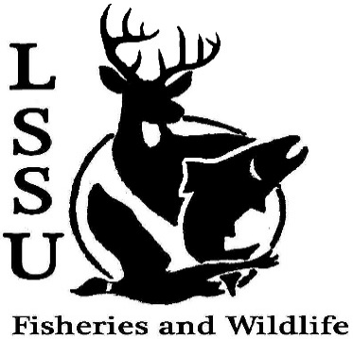
LSSU Fisheries and Wildlife Club

Meeting of September 4th, 2019

Meeting Start: 8:06

1st:Kaitlyn 2nd:Connor

Officers

President: Riley Waterman Rwaterman@lssu.edu (269) 806-0980
Vice President: Austin Heslinga
Secretary: Trenton Schipper
Treasurer: Michael Gray
Committee Chairs:
      - Events- TBD
      - Social Media- Evan Farrier
      - Fundraising- TBD
      - Apparel- Ben Short
- Officer’s Report
  - Vice President- Austin Heslinga
  - Secretary- Trenton Schipper
  - Treasurer – Michael Gray 1st:Avery 2nd:Josh
- Old Business
  - Drummond Island Grouse Lekking Survey Evan Gave a Short word on what this event was about.
  - MIAFS Stream Habitat Assessment Workshop
  - Nmé Celebration
  - Three Shores Cisma Frogbit Pulling
  - Summer
- New Business
  - TWS Video and Mission Statement
  - Michigan Bass Nation Tournament- September 12-15th George spoke a word
  - Freshwater Stewardship Corps Bird Migration Month – Sept 10, 14, 21
  - Elk Viewing Trip- September 20-22nd
  - Freshwater Mussel ID with EGLE biologists, October 25 – 2-5pm
  - Whitefish Dinner- October 26th
  - Cook Inlet Aquaculture Association Meet and Greet- November 18th
  - Midwest Fish and Wildlife Conference January 26-29th
  - Think about committee chairs
  - Think about event ideas for this year
  - Raffle prizes for whitefish dinner (tax write-off form on website)
  - Summer Facebook Competition
    - Fishing Competition
    - #NoFilter Cellphone Competition
  - Send pictures of past events to officers
  - Senior Research help?
  - Have an idea for a speaker or a Meet and Greet at Laker Hall? Talk to Events committee or any of the officers!
  - Check your email for notifications!

- Reminders
  - Please take photos and videos at FWC events!
  - Pay your dues!
  - Like the Facebook page!
  - Follow us on Instagram @lssufwc
  - Visit our Website! http://www.lssufwc.weebly.com/

Next Meeting: September 18th

End Time: 8:59

1st:Josh 2nd:Evan

