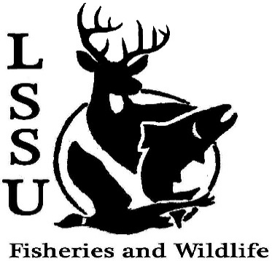
LSSU Fisheries and Wildlife Club

Meeting of March 6th, 2019
Start: 8:01pm
1st:Shaun 2nd: Mary

Officers

President: Conner Johnson cjohnson30@lssu.edu (641)-919-0723
Vice President: Evan Farrier
Secretary: Kaitlyn Yantz
Treasurer: Britney Weaver
Committee Chairs:
      - Events- Patrick James
      - Social Media- Evan Farrier
      - Fundraising- Shaun O’Connor
      - Apparel- Douglas Kreutzkamp
- Officer’s Report
  - Vice President- Evan Farrier
  - Secretary- Kaitlyn Yantz
  - Treasurer – Britney Weaver 1st Evan 2nd Justin
- Old Business
  - Officer Nominations
  - CFRE Ice-Fishing Trip
  - Turtle Workshop
  - Chili Cook-Off 7 different chilis
- New Business

  - MI Fish and Wildlife Conference March 13-15th Approved (24)
    - Treetops Resort in Gaylord, MI
    - Fill out Travel Forms
    - Donate Raffle Prizes
  - Approve MI F&W Funding
  - Tracking Workshop April 3rd
  - New Officer Elections
Presidential: Britany (8) Riley (13) Zack (3)
VP: Britany (6) Mike (1) Austin (14) Riley (2)
Treasurer: Mike Gray
Secretary: Ryan (2) Zack (4) Trenton (16)
  - Senior Research help?
  - Have an idea for a speaker or a Meet and Greet at Laker Hall? Talk to Events committee or any of the officers!
  - Check your email for notifications!

- Reminders
  - Please take photos and videos at FWC events!
  - Pay your dues!
  - Like the Facebook page!
  - Follow us on Instagram @lssufwc
  - Visit our Website! http://www.lssufwc.weebly.com/

Next Meeting: March 20, 2019

End time: 8:50pm

1^{st Ethan}

2^{nd Ben}

