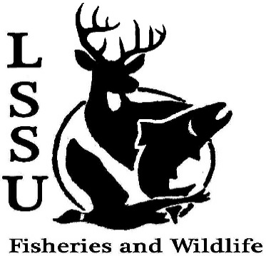
LSSU Fisheries and Wildlife Club

Meeting of February 19th, 2020

Start time:8:01

1st:Molly 2nd:Josh

Officers

President: Riley Waterman Rwaterman@lssu.edu (269) 806-0980
Vice President: Austin Heslinga
Secretary: Trenton Schipper
Treasurer: Michael Gray
Committee Chairs:
      - Events- Ben Short
      - Social Media-
      - Fundraising- Jasmin Estes
      - Apparel- Avery Feldmeier
- Officer’s Report
  - Vice President- Austin Heslinga
  - Secretary- Trenton Schipper
  - Treasurer – Michael Gray 1st:Evan 2nd:Avery
- Old Business
  - Meet and Greet with Sam Griffin: Huron Pines Americorps
  - Meet and Greet with USFS (Hiawatha National Forest)
- New Business
  - Job Description- Britney Weaver
  - CFRE Work and Volunteer Opportunities
  - MI AFS Annual Meeting- March 11-13th, Mount Pleasant, MI (CMU)
  - MITWS March 18th-20th, Bellaire- (Head Counts)
  - Officer Nominations nominations at bottom
  - Think about committee chairs
  - Think about event ideas for this year
  - Raffle prizes for whitefish dinner (tax write-off form on website)
  - Send pictures of past events to officers
  - Senior Research help?
  - Have an idea for a speaker or a Meet and Greet at Laker Hall? Talk to Events committee or any of the officers!
  - Check your email for notifications!

- Reminders
  - Please take photos and videos at FWC events!
  - Pay your dues!
  - Like the Facebook page!
  - Follow us on Instagram @lssufwc
  - Visit our Website! http://www.lssufwc.weebly.com/

Next Meeting: March 11th

End Time: 8:36

1st:Evan 2nd:Jacob

President nominations: Austin Heslinga maybe, Trenton Schipper maybe, Michael Hatten sending it

Vice president nominations: Ben Short yes, Jacob Lahroff maybe, Trenton Schipper maybe, Tyler Somerville maybe, Andrew Kaiser yes, Abby Boyd yes, Molly yes

Treasurer nominations: Jake Somerville yes, Ben Short yes, Molly maybe yes, George, Avery Feldmeier

Secretary nominations: Austin Heslinga yes, Jacob Lahroff yes, Kaitlin maybe, Jasmin yes

