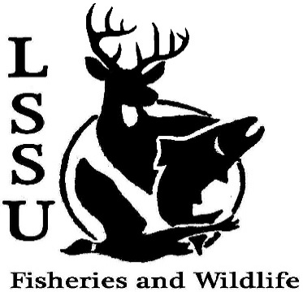
LSSU Fisheries and Wildlife Club

Meeting of February 13th, 2019
Start: 8:00

Officers

President: Conner Johnson cjohnson30@lssu.edu (641)-919-0723
Vice President: Evan Farrier
Secretary: Kaitlyn Yantz
Treasurer: Britney Weaver
Committee Chairs:
      - Events- Patrick James
      - Social Media- Evan Farrier
      - Fundraising- Shaun O’Connor
      - Apparel- Douglas Kreutzkamp
- Officer’s Report
  - Vice President- Evan Farrier
  - Secretary- Kaitlyn Yantz
  - Treasurer – Britney Weaver
- Old Business
  - Resume and Cover Letter Workshop
  - Tubing Trip No one died
  - Movie Night The great outdoors
  - Midwest Fish and Wildlife Conference Research presentation, current events, networking, 5 that went,
- New Business
  - CFRE Ice Fishing Trip
    - February 16th
  - Chili Cook-Off
    - Feb. 18th
  - Movie Nights
    - Next Movie: A River Runs Through It
    - @ Laker Hall
  - Euchre Tournament Interest?
    - Buy-in cost? 5 a piece
  - MI Fish and Wildlife Conference March 13-15th
    - Treetops Resort in Gaylord, MI
    - Registration Open
    - Great Opportunity for Everyone!
  - Radio Telemetry Workshop March 19th Turtle workshop 21st
  - Tracking Workshop April 3rd
  - Trip to Oden Fish Hatchery April 6th
  - New Officer Nominations
President: Britney (2 nominations) Zack Walters, Riley Waterman
VP: Big Mike (accept) Britney, Doug K, Zack Walters, Austin Heslinga, Ryan Spraque,
Treasurer: Mike Gray
Secretary: Trenton Schipper, Ryan Spraque, Zack Walters,

  - Senior Research help?
  - Have an idea for a speaker or a Meet and Greet at Laker Hall? Talk to Events committee or any of the officers!
  - Check your email for notifications!

- Reminders
  - Enjoy Your Spring Break!
  - Please take photos and videos at FWC events!
  - Pay your dues!
  - Like the Facebook page!
  - Follow us on Instagram @lssufwc
  - Visit our Website! http://www.lssufwc.weebly.com/

Next Meeting: March 6, 2019

End 8:30 1st Ethan 2nd Zack

