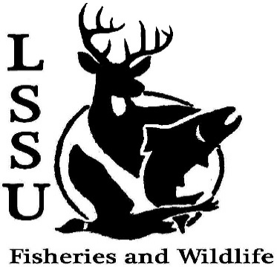
LSSU Fisheries and Wildlife Club

Meeting of December 4th, 2019

Start time:8:02

1st :Mike 2nd:Jake

Officers

President: Riley Waterman Rwaterman@lssu.edu (269) 806-0980
Vice President: Austin Heslinga
Secretary: Trenton Schipper
Treasurer: Michael Gray
Committee Chairs:
      - Events- Ben Short
      - Social Media- Evan Farrier
      - Fundraising- Jasmin Estes
      - Apparel- Avery Feldmeier
- Officer’s Report
  - Vice President- Austin Heslinga
  - Secretary- Trenton Schipper
  - Treasurer – Michael Gray 1st:Evan 2nd:Josh
- Old Business
  - Cook Inlet Aquaculture Association Meet and Greet
  - Nick Moorman Meet and Greet
- New Business
  - CFRE Student Holiday Party- December 12th, 12-1:30 Hillside Hall
  - Midwest Fish and Wildlife Conference January 26-29th
  - MI AFS Annual Meeting- March 11-13th, Mount Pleasant, MI (CMU) Call for Abstracts Posted
  - Wendy Saks scholarship Motion for Approval: Everyone
  - Think about committee chairs
  - Think about event ideas for this year
  - Raffle prizes for whitefish dinner (tax write-off form on website)
  - Send pictures of past events to officers
  - Senior Research help?
  - Have an idea for a speaker or a Meet and Greet at Laker Hall? Talk to Events committee or any of the officers!
  - Check your email for notifications!

- Reminders
  - Please take photos and videos at FWC events!
  - Pay your dues!
  - Like the Facebook page!
  - Follow us on Instagram @lssufwc
  - Visit our Website! http://www.lssufwc.weebly.com/

Next Meeting: January 15th

End Time: 8:15

1st:Evan 2nd:Evan

