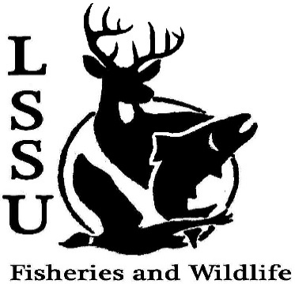
LSSU Fisheries and Wildlife Club

Meeting of November 13th, 2019

Start Time:8:02

1st:Molly 2nd:Evan

Officers

President: Riley Waterman Rwaterman@lssu.edu (269) 806-0980
Vice President: Austin Heslinga
Secretary: Trenton Schipper
Treasurer: Michael Gray
Committee Chairs:
      - Events- Ben Short
      - Social Media- Evan Farrier
      - Fundraising- Jasmin Estes
      - Apparel- Avery Feldmeier
- Officer’s Report
  - Vice President- Austin Heslinga
  - Secretary- Trenton Schipper
  - Treasurer – Michael Gray 1st:Evan 2nd:Jake
- Old Business
  - Meet and Greet with Dr. Gary Roloff
  - Atlantic Broodstock/Egg take
  - Mancelona High School Visit- Fish Aging/Macroinvertebrate Lab
  - Snake Workshop
- New Business
  - Cook Inlet Aquaculture Association Meet and Greet- November 18th; Laker Hall 6 p.m.
  - Senior Research Help- Piping Plover Behavioral Observations; November 20th 8 p.m. CRW 204
  - TWS Outstanding Undergrad Applications- Due November 30th
  - Midwest Fish and Wildlife Conference January 26-29th
  - MI AFS Annual Meeting- March 11-13th, Mount Pleasant, MI (CMU) Call for Abstracts Posted
  - Think about committee chairs
  - Think about event ideas for this year
  - Raffle prizes for whitefish dinner (tax write-off form on website)
  - Send pictures of past events to officers
  - Senior Research help?
  - Have an idea for a speaker or a Meet and Greet at Laker Hall? Talk to Events committee or any of the officers!
  - Check your email for notifications!

- Reminders
  - Please take photos and videos at FWC events!
  - Pay your dues!
  - Like the Facebook page!
  - Follow us on Instagram @lssufwc
  - Visit our Website! http://www.lssufwc.weebly.com/

Next Meeting: December 4th (Last of the semester)

End Time: 8:16

1st:Evan 2nd:Ben

