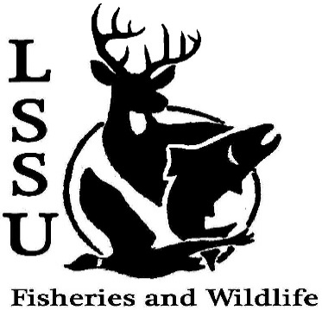
LSSU Fisheries and Wildlife Club

Meeting of October 30th, 2019

Start time:8:00

1st:Evan 2nd:Avery

Officers

President: Riley Waterman Rwaterman@lssu.edu (269) 806-0980
Vice President: Austin Heslinga
Secretary: Trenton Schipper
Treasurer: Michael Gray
Committee Chairs:
      - Events- Ben Short
      - Social Media- Evan Farrier
      - Fundraising- Jasmin Estes
      - Apparel- Avery Feldmeier
- Officer’s Report
  - Vice President- Austin Heslinga
  - Secretary- Trenton Schipper
  - Treasurer – Michael Gray 1st:Evan 2nd:Josh
- Old Business
  - Dr. Garvon Deer Shining Kaiser gave a word
  - Dr. Allans Pond Sampling
  - Meet and Greet with Dr. Dick Curnow and Mike Jaeger
  - Freshwater Mussel ID with EGLE biologists Donnie gave a word
  - Whitefish Dinner
  - Community Conversation on Great Lakes, Great Economy, FSC Connor gave a word

- New Business
  - Sullivan’s Creek Lake Trout Spawning Trip- Nov 6th
  - Atlantic Salmon Broodstock, ARL October 30th and 31st
  - Mancelona High School Visit/Club Activity; Macroinvertebrate Lab- October 31st 9:30-10:15 SEND EMAIL!!
  - Snake ID Workshop- Gauge Interest
  - Meet and Greet with Dr. Gary Roloff- November 6th, 7pm; Laker Hall
  - Cook Inlet Aquaculture Association Meet and Greet- November 18th; Laker Hall
  - TWS Outstanding Undergrad Applications- Due November 30th
  - Midwest Fish and Wildlife Conference January 26-29th
  - MI AFS Annual Meeting- March 11-13th, Mount Pleasant, MI (CMU)
  - Think about committee chairs
  - Think about event ideas for this year
  - Raffle prizes for whitefish dinner (tax write-off form on website)
  - Send pictures of past events to officers
  - Senior Research help?
  - Have an idea for a speaker or a Meet and Greet at Laker Hall? Talk to Events committee or any of the officers!
  - Check your email for notifications!

- Reminders
  - Please take photos and videos at FWC events!
  - Pay your dues!
  - Like the Facebook page!
  - Follow us on Instagram @lssufwc
  - Visit our Website! http://www.lssufwc.weebly.com/

Next Meeting: November 13th

End Time:8:20

1st:Evan 2nd:Jake

