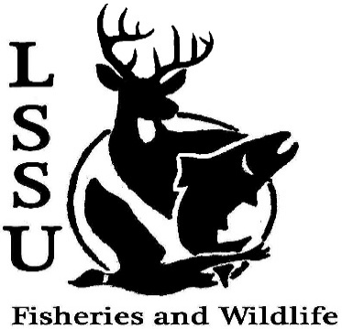
LSSU Fisheries and Wildlife Club

Meeting of October 2nd, 2019

Start Time: 8:01

1st:Evan 2nd:Jacob

Officers

President: Riley Waterman Rwaterman@lssu.edu (269) 806-0980
Vice President: Austin Heslinga
Secretary: Trenton Schipper
Treasurer: Michael Gray
Committee Chairs:
      - Events- Ben Short
      - Social Media- Evan Farrier
      - Fundraising- TBD
      - Apparel- Avery Feldmeier
- Officer’s Report
  - Vice President- Austin Heslinga
  - Secretary- Trenton Schipper Last Meeting Sept. 18, 27 minutes
  - Treasurer – Michael Gray 1st:Connor 2nd:Evan
- Old Business
  - Freshwater Stewardship Corps Bird Migration Month – Whitefish Point
  - Elk Viewing Trip
  - Huron pines Americorps- Meet and Greet
  - FSC Nocturnal Birding/Yooperlite Rocks- Whitefish Point
- New Business
  - Sullivan’s Creek Lake Trout Spawning- (many dates available)
  - Raffle Blitz- October 7th, 9th, and 17th
  - Environmental Law Meet and Greet, Dennis Donohue, October 9th, 6:30 p.m.
  - Dr. Garvon Deer Shining- October 1-31st, (many spots and times)
  - Piping Plover Senior Research Help; Behavioral Observations- October 9th, 8 pm CRW 204
  - Dr. Allans Pond Sampling, October 18-19th
  - Freshwater Mussel ID with EGLE biologists, October 25th – 2-5pm
  - Whitefish Dinner- October 26th
  - Mancelona High School Visit/Club Activity; Macroinvertebrate Lab- October 31st 10:45-11:30
  - Snake ID Workshop- Gauge Interest
  - Meet and Greet with Dr. Gary Roloff- November 6th, 7pm; Laker Hall
  - Cook Inlet Aquaculture Association Meet and Greet- November 18th; Laker Hall
  - TWS Outstanding Undergrad Applications- Due November 30th
  - Midwest Fish and Wildlife Conference January 26-29th
  - MI AFS Annual Meeting- March 11-13th, Mount Pleasant, MI (CMU)
  - Think about committee chairs
  - Think about event ideas for this year
  - Raffle prizes for whitefish dinner (tax write-off form on website)
  - Send pictures of past events to officers
  - Senior Research help?
  - Have an idea for a speaker or a Meet and Greet at Laker Hall? Talk to Events committee or any of the officers!
  - Check your email for notifications!

- Reminders
  - Please take photos and videos at FWC events!
  - Pay your dues!
  - Like the Facebook page!
  - Follow us on Instagram @lssufwc
  - Visit our Website! http://www.lssufwc.weebly.com/

Next Meeting: October 16th

End Time:8:28

1st:Drew 2nd: Avery

