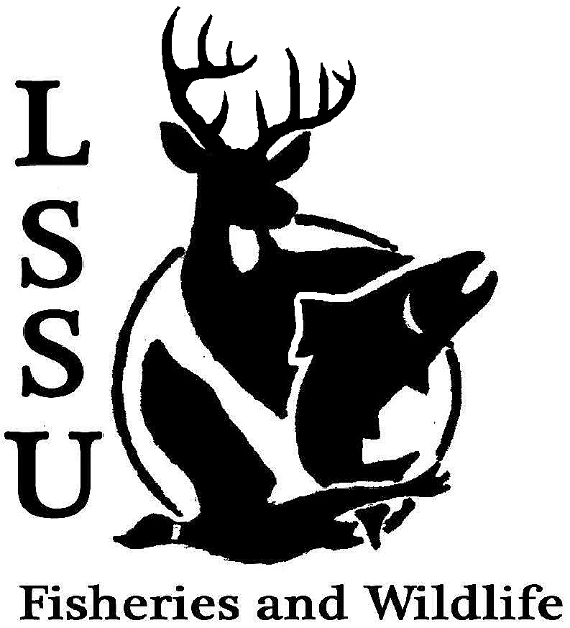
LSSU Fisheries and Wildlife Club
Meeting of January 28th, 2015
Kyle Hafeman: khafeman@lssu.edu (906) 295-1585
Meeting called to order at 8:09 pm

- Officers Report
  - Secretary – Addie Dutton Addie reported the minutes from the previous meeting. Motion to approve first by Eddie and second by Jake. Motion passes.
  - Treasurer – Jake Truitt Jake presented the minutes from the previous meetings with up to date earnings and expenses. Motion for approval first by Trevor and second by Coleson. Motion passes.
  - Event Committee – Maddy and Gislaine, lssufwcevent@gmail.com
    - Tracks and Telemetry Workshop – Jan. 31st, 2pm If you are planning on attending this, please meet in the Crawford lobby on Sunday
    - Pedro Antunes (Invasive Plants) – Feb. 11th, 7pm CRW 205 Great speaker this evening talking about the effects of the Emerald Ash Bore and how bad it has become. Please plan to attend the next presentation if you are free
    - Katie Koch (Bird Conservation) – March 27th, 7pm, location TBA
    - Ms. Purple’s class – Club Demonstration Ideas Volunteers are needed to help dissect Atlantic Salmon in the classroom. One Thursday between 12pm-3pm with 6th graders
    - MI Bird Conservation Workshop
      - March 19-21, Tustin, MI Talk with Dr. Garvon about money and if you are planning on attending this conference.
  - Raffle Committee – Cliff Please collect any raffle items for the F3T tour and get them to Cliff as soon as you have possession of them!
- New Business
  - MI AFS – Reimbursement
    - Hotels - $330, Travel~$550 The meeting was a good time filled with familiar faces, breakfast sneezes, and only LSSU students were there which showed a good representation for the club! Motion to reimburse the club members and biology $880 first by Garret and second by James all in favor to reimburse the money owed to travel to the conference.
  - Midwest F&W Conference – Meet after meeting Next year Midwest will be in conjunction with MIAFS and it will be in Grand Rapids! If you are a fisheries student, strongly consider attending this meeting!!
  - Fly Fishing Film Tour – February 21st, 6pm Fine Arts Center If you would like to purchase tickets, please see Paul in the ROC they are $5 for students. If you are helping with the film, you do not have to purchase a ticket.
  - Nongame and Larval Fish ID Course – March 10th and 11th, MSU
    - Contact Kyle Hafeman for more information Register yourself and make sure if you take one of the spots that you are actually going to attend.
  - TWS Student Conclave – March 27-29th, Sandstone MN
    - Registration is $80, first come first serve. 150 spots open Jayne will have more information and the registration packet hopefully by the next meeting. It is a fun event and you should consider going!
  - Doug Reeves Visit He will be here March 11th for the entire day and will be going out to dinner with interested students as well!
  - Meet and Greet Times? Members decided that the best time for meet and greets this semester will be Thursdays at 7:00 pm.
  - Senior Research help?
- Reminders
  - Please take photos at FWC events!
  - Pay your dues!
Next Meeting: Wednesday February 18th @ 8 PM
Meeting adjourned at 8:46pm first by Logan and second by Trevor

