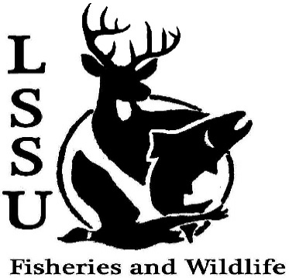
LSSU Fisheries and Wildlife Club

Meeting of September 5th, 2018
Start time: 8:05
1st Benny 2nd Shaun

Officers

President: Conner Johnson cjohnson30@lssu.edu (641)-919-0723
Vice President: Benjamin Larrabee
Secretary: Kaitlyn Yantz
Treasurer: Britney Weaver
Committee Chairs:
      - Events-Patrick James, Evan Farrier
      - Apparel- Douglas Kreutzkamp
- Officer’s Report
  - Vice President – Benjamin Larrabee
  - Secretary- Kaitlyn Yantz
  - Treasurer – Britney Weaver Approved: 1st Patty 2nd Evan
- Old Business
  - Summer Break
- New Business
  - Summer Facebook Competition More info soon
    - Fishing Competition Big fish, little fish
    - No Filter Cellphone Competition
  - Elk Viewing Trip with Kelly Sept. 21st-23rd Gaylord, Doug Rethes- division chief. Brian- elk management
  - Whitefish Dinner Oct. 27th
    - Raffle Prizes All help is needed
  - Youth in the Outdoors in Seney Oct 13th. Seney wildlife refuge, helping middle school kids doing macroinvertebrate lab
  - Pine Pulling and Pond Sampling with Dr. Allen Yak burgers
  - Michigan Fish and Wildlife Conference March 13-15
    - Abstracts due September 30th
  - T-Shirt Drawing Krystal Smith
  - Apparel Ideas with Doug Order apparel, survey sheet going around. No camo
  - Deer shining Sign up sheet went around
  - Senior Research help? Hadley needs help
  - Have an idea for a speaker or a Meet and Greet at Laker Hall? Talk to Events committee or any of the officers!
  - Biobash – 16th (18 people) or 23rd (like 5) Hang out at Laker hall
  - Check your email for notifications!

- Reminders
  - Please take photos and videos at FWC events!
  - Pay your dues! $5 per semester
  - Like the Facebook page!
  - Visit our Website! http://www.lssufwc.weebly.com/

Next Meeting: September 19, 2018

End time: 8:22 1st Patty 2nd Shawn

