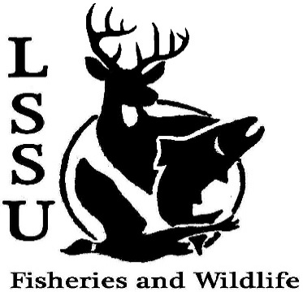
LSSU Fisheries and Wildlife Club
Meeting of September 23rd, 2015
Started at 7pm
Officers
President: Cliff Pattinson: cpattinson@lssu.edu (269) 841-6472
VP: Michelle Kane
Secretary: Autumn Wiese
Treasurer: John Milan
Events Committee Co-Chairs: Chris Cortell & Matt Grieb
Fundraising Committee Chair: Alleigh Sexton

- Officer’s Report
  - Vice President – Michelle Kane No report
  - Secretary – Autumn Wiese Showed last week’s min. Approved first by Anthony, second by Trevor.
  - Treasurer – John Milan Showed treasurer’s report. Approved first by Anthony, second by Trevor.

- Old Business
  - LRBOI Sturgeon Release Cliff showed a short video and pictures.
  - Elk Viewing & Camping Trip Michelle showed a short PowerPoint about the trip

- New Business
  - Emails Some students aren’t receiving emails, let Autumn know.
  - Importance of Dues Cliff gave a presentation.
  - Raffle Blitzes: October 9th and 23rd, Afternoons before 5 Sign up passed around.
  - Pond Sampling – Sept. 24-25th; 3 pm, Library Parking Lot Sign up passed around.
  - Biogames – Date TBA (Originally Oct. 10th) - need volunteers to help
Organize Sign up passed around.

  - Whitefish dinner – Nov. 21st Sign up passed around.
    - Need volunteers to help coordinate
      - 2 Shifts, Dinner for free if you work either shift
    - Need raffle items
    - Contact Events Committee (Chris and Matt)
  - Abstracts for Midwest Fish and Wildlife Conference, Grand Rapids, MI (January 24-27—Save the Date!) due October 1—mentor must proofread before submission
    - Need raffle items

  - Volunteer opportunities – Dr. Moerke & Dr. Kap’s fish migration project needs volunteers on Tuesday and Thursdays to help with fish sampling (must be free all day)
  - Senior Research help?

- Reminders
  - Please take photos at FWC events!
  - Pay your dues!
  - Like the Facebook page!
  - Visit our Website! http://www.lssufwc.weebly.com/

Next Meeting: October 7th, 2015 @ 7 PM

Meeting ended at 7:18pm approved first by Trevor, second by Cole.

