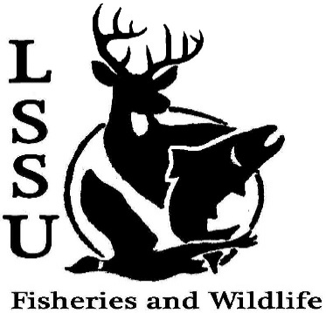
LSSU Fisheries and Wildlife Club
Meeting of September 21st, 2016
Called to Order at 8pm
1st by Nick, 2nd by Mike
Officers
President: Elizabeth Cilman ecilman@lssu.edu (989) 305-8599
Vice President: Juliet Golob
Secretary: Kelly Mildebrandt
Treasurer: Katherine Skubik

- Officer’s Report
  - Vice President – Juliet Golob
  - Secretary- Kelly Mildebrandt - 1st by Jac, 2nd by Patrick
  - Treasurer – Katherine Skubik - 1st by Mike, 2nd Marry
  - Committee report (Chairs)
    - Fundraising- Cliff Pattinson
    - Events-Riley Waterman
    - Apparel- Juliet Golob

- Old Business
  - Elk viewing
  - LRBOI Sturgeon Release
- New Business
  - Raffle Blitz- September 22nd at 1 pm – Meet in the library parking lot
  - Cisco Tagging- September 25th
  - Midwest Fish and Wildlife Conference (Lincoln, NE) – Deadline extended abstracts due September 30th
  - Biogames- Rescheduled September 30th at 3:30pm
  - ROC Monumental Film Festival- October 5th at 6:30
  - GLSW Parade- October 15th 4:00pm
  - Pine Pulling with Dr. Allen-October 1st?
  - Pond Sampling- October 1st and 2nd or October 7th and 8th
  - Owl Banding- October 21st or 22nd
  - Whitefish Dinner Fundraiser -November 12th
    - Need volunteers
    - Need silent auction items
  - Facebook fishing contest – Biggest: Jake Larson, Smallest: Twan
  - Have an idea for an event? Talk to Events Committee or any of the Officers!
  - Have an idea for a speaker or a Meet and Greet at Laker Hall? Talk to Events committee or any of the officers!
  - Senior Research help?

- Reminders
  - Please take photos and videos at FWC events!
  - Pay your dues!
  - Like the Facebook page!
  - Visit our Website! http://www.lssufwc.weebly.com/

Next Meeting: October 5th, 2016

Called to a Close at 8:47pm
1st by Twan, 2nd by Patrick

