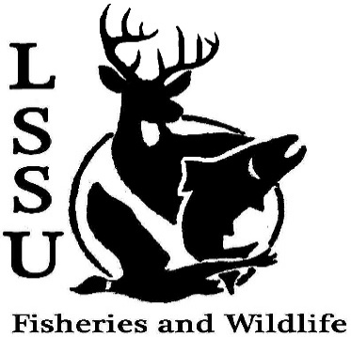
LSSU Fisheries and Wildlife Club
Meeting of March 8th, 2017
Opened @8pm
1st Mary 2nd Cole
Officers
President: Elizabeth Cilman ecilman@lssu.edu (989) 305-8599
Vice President: Juliet Golob
Secretary: Kelly Mildebrandt
Treasurer: Katherine Skubik
Committee Chairs:
      - Fundraising- Cliff Pattinson
      - Events-Riley Waterman
      - Apparel- Juliet Golob

- Officer’s Report
  - Vice President – Juliet Golob
  - Secretary- Kelly Mildebrandt Motion by Cliff 1st Mary 2nd Mike
  - Treasurer – Katherine Skubik Motion by Mike 1st Mary 2nd Patrick
- Old Business
  - Spring Break
  - Resume Workshop Good time, Good work Dr. Moerke, learned formatting and wording
  - CLMCCA Preschool Visit Adorable kids, had a good time
- New Business
  - Funding: Total $1,240 Asking as a whole, anything not used goes back into funds
    - Presenters Registration- AFS $250, TWS $40
    - MI AFS Conference-$200 for university vehicle (15 passenger bus)
    - MI TWS Conference- $200 for two rooms
    - TWS Student Conclave- $550 for a university vehicle (car)
Mike asked if the TWS events were the same
Motion made by Cliff 2nd by Katherine, Motion passed, will get a recap of money actually spent afterward
  - Snowy Owl Trip- March 12th Meet at 10 am in the Library parking lot
  - Michigan AFS Conference- Wednesday-Thursday (noon), March 15th-16th in Mackinaw City ( Mackinaw Beach and Bay Inn and Suites)
    - NEED RAFFLE PRIZES MSU has a handful of prizes, to receive funding must complete travel application, 2 raffle items or lead an event, pay dues
    - More detail can be found at: Meet after meeting http://michigan.fisheries.org/annual-meeting/upcoming-meeting/
  - TWS Annual Meeting- March 16th-17th Treetops Resort, Gaylord, MI
    - More detail can be found at: http://michigantws.wixsite.com/mitws/annual-conference
  - TWS North Central Student Conclave- March 24th-26th
    - Camp Tecumseh: Brookston, Indiana Put a star by your name if you can drive a university vehicle
    - Details and registration packet found at: http://wildlife.org/next-generation/annual-conclaves/
  - Relay For Life- March 25th 11am-11pm
    - http://main.acsevents.org/site/TR/?fr_id=81487&pg=team&team_id=2157176 Please sign up, no Buffalo Wild Wings, can sign up at event
    - Vote on new officers:
    - President:
      - Will Marosi President elect
      - Riley Waterman Moved down
      - Mary Markel Moved down
    - Vice President :
      - Patrick James Not moved
      - Will Marosi
      - Hadley Reed Not moved
      - Mary Markel Not moved
      - VP elect
    - Treasurer :
      - Cole VanOosten Tie for elect/ Treasurer elect
      - Michael Gray Not moved
      - Bryant Smak Tie for elect
      - Ryan Sprange Not moved
      - Patrick James Not moved
    - Secretary:
      - Anna Bush Secretary elect
      - Mary Markel
      - Hadley Reed
    - Officer Instatement: March 22nd (next meeting)
  - Have an idea for an event? Talk to Events Committee or any of the Officers!
  - Have an idea for a speaker or a Meet and Greet at Laker Hall? Talk to Events committee or any of the officers!
  - Senior Research help?
Cliff talks about student gov. Ran after president, the only fish and wildlife major in student gov, important to have someone represent FWC, sign up in Orgsync, go to Cliff with any questions
Reminders
  - Please take photos and videos at FWC events!
  - Pay your dues!
  - Like the Facebook page!
  - Visit our Website! http://www.lssufwc.weebly.com/ Travel app here
Next Meeting: March 22nd, 2017
Closed @ 8:52pm
1st Emily 2nd Mary

