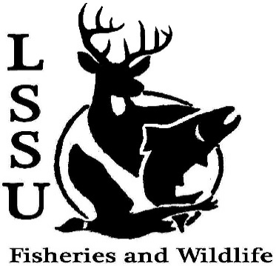
LSSU Fisheries and Wildlife Club
Meeting of November 4th, 2015
Started @ 7pm
Officers
President: Cliff Pattinson: cpattinson@lssu.edu (269) 841-6472
VP: Michelle Kane
Secretary: Autumn Wiese
Treasurer: John Milan
Events Committee Co-Chairs: Chris Cortell & Matt Grieb
Fundraising Committee Chair: Alleigh Sexton

- Officer’s Report
  - Vice President – Michelle Kane
  - Secretary – Autumn Wiese 1st by Anthony, 2nd by Graham
  - Treasurer – John Milan 1st by Anthony, 2nd by Cole
- Old Business
  - Biogames PowerPoint was shown
  - Cisco Tagging Asked to come back for egg take
  - Atlantic Salmon Broodstock Netting Videos shown and Rodger said “thank you for the help”
  - Laker Legion Box Club want to possibly get the box again
- New Business
  - Atlantic Salmon Broodstock Work
    - Begins Nov. 5th, 8:00-11:30 AM
    - More details after tomorrow
  - Wildlife Telemetry Workshop – Nov. 7th, 1 pm, CRW 122 – Gislaine Peters
  - Whitefish dinner – Nov. 21st
    - Get some tickets!
    - Don’t forget Faculty!
    - Workers needed, especially 2nd shift
    - Need volunteers to help coordinate
      - 2 Shifts
      - $15 prior to dinner
    - Need raffle items by 11-13-15
    - Contact Events Committee (Chris and Matt)
  - Midwest Fish and Wildlife Conference, Grand Rapids, MI – January 24-27
    - Sign-up and registration BEFORE Nov. 15
    - Scholarship for underclassmen extended to Nov. 6th by 5 PM
    - Raffle
      - Official letter from Gary Whalen for Thanksgiving / Winter Break
      - BIG TICKET
  - Fish movement project – contact Dr. Moerke if you are interested in a day of sampling migratory fishes; help needed Tuesdays and Thursdays
  - International Association of Great Lakes Research fisheries/aquatic sciences scholarships
    - Several available for upperclassmen
    - http://www.iaglr.org/scholarships/rodgers-scholarship/
    - Contact Dr. Kapuscinski for questions/details
  - AFS North Central Division Walleye Technical Committee Scholarship Student must be doing research on walleye to receive the scholarship
    - $100 travel grant for Midwest Conference
    - Due Dec. 1st
    - Contact Cliff for Application
  - AFS Student Chapter Video Contest
    - Short videos (less than 2 minutes)
    - Uploaded to the MIAFS YouTube Channel
    - $100 first prize
    - Deadline – Dec. 18th
  - AFS photos
  - New meeting time/day? Wednesdays at 7-16 & at 8-20 possible doodle poll
  - Senior Research help? Maddie needs rabbits
  - Rachel announced SCB meetings at 6 also a cleanup Sunday at 1 at Sherman park

- Reminders
  - Please take photos and videos at FWC events!
  - Pay your dues!
  - Like the Facebook page!
  - Visit our Website! http://www.lssufwc.weebly.com/

Next Meeting: November 18th, 2015 @ 7 PM

Ended at 7:30 1st by Anthony, 2nd Chris

