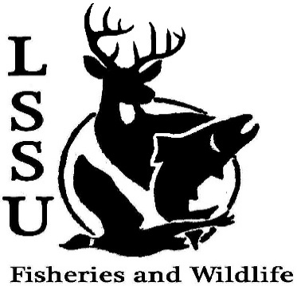
LSSU Fisheries and Wildlife Club
Meeting of November 18th, 2015
Started @ 7pm
Officers
President: Cliff Pattinson: cpattinson@lssu.edu (269) 841-6472
VP: Michelle Kane
Secretary: Autumn Wiese
Treasurer: John Milan
Events Committee Co-Chairs: Chris Cortell & Matt Grieb
Fundraising Committee Chair: Alleigh Sexton

- Officer’s Report
  - Vice President – Michelle Kane Needs Whitefish $ and Tickets
  - Secretary – Autumn Wiese 1st Anthony 2nd by Cole
  - Treasurer – John Milan 1st Anthony 2nd by Cole
- Old Business
  - Atlantic Salmon Egg Take
  - Wildlife Telemetry Workshop
    - Both events went well, all enjoyed it
- New Business
  - Atlantic Salmon Egg Take
    - Thursday, Nov. 19th, 8:00 – Noon
    - LAST DAY
  - Net Pen Meeting with Michigan DNR – Thursday, Nov. 19th
    - Gaylord, MI
    - http://www.michigan.gov/som/0,4669,7-192-47796-368780--,00.html
    - Contact Dr. Kapuscinski for details
  - Assistance with collecting yellow perch for inquiry project – Lucas Meehan
  - Whitefish dinner –Saturday, Nov. 21st
    - TURN IN MONEY OR UNSOLD TICKETS TONIGHT
    - Workers / volunteers meet AFTER MEETING
    - Contact Events Committee (Chris and Matt)
  - Midwest Fish and Wildlife Conference, Grand Rapids, MI – January 24-27
    - Raffle
      - Official letter from Gary Whalen for Thanksgiving / Winter Break
      - BIG TICKET
  - Fish movement project still ongoing– contact Dr. Moerke if you are interested in a day of sampling migratory fishes; help needed Tuesdays and Thursdays
  - Science Road Tour over Spring Break w/ Julia Roque – Dr. Moerke If interested let Dr. Moerke know
  - AFS Student Chapter Video Contest
    - Short videos (less than 2 minutes)
    - Uploaded to the MIAFS YouTube Channel
    - $100 first prize
    - Deadline – Dec. 18th
  - AFS photos
  - Senior Research help?.
Maddy need rabbits, I need help with counting ducks
Cisco rearing going on

- Reminders
  - Please take photos and videos at FWC events!
  - Pay your dues!
  - Like the Facebook page!
  - Visit our Website! http://www.lssufwc.weebly.com/

Next Meeting: December 2nd, 2015 @ 7 PM
Ended @ 7:40pm 1st by Ben, 2nd by Chris
Scholarship for Midwest Kelly Mildebrandt and Katherine Skubik

