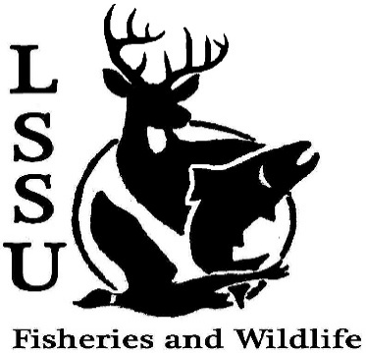
LSSU Fisheries and Wildlife Club
Meeting of November 16th, 2016
Called to Order @8pm
1st by Cole, 2nd by Mike
Officers
President: Elizabeth Cilman ecilman@lssu.edu (989) 305-8599
Vice President: Juliet Golob
Secretary: Kelly Mildebrandt
Treasurer: Katherine Skubik
Committee Chairs:
      - Fundraising- Cliff Pattinson
      - Events-Riley Waterman
      - Apparel- Juliet Golob

- Officer’s Report
  - Vice President – Juliet Golob
  - Secretary- Kelly Mildebrandt 1st by Mary, 2nd by Patrick
  - Treasurer – Katherine Skubik 1st by Mike, 2nd by Cole
- Old Business
  - Meet and Greet- Steven Gambicki Presented by Liz→ held at Laker Hall, went well.
  - Meet and Greet- Emily Martin Presented by Anna→ Discussed jobs
  - Laker Legion Box Presented by Mike, Cliff, and Kelly→ The game went well, wanted more food from catering
  - Atlantic Salmon Egg Take and Netting Presented by Cliff and the Club→ went well, thinking about doing more
  - Whitefish Dinner
    - Thank you everyone for all of your help!
Presented by the Club→ Dinner went smoothly, made a good profit
- New Business
  - Apparel is in! contact Juliet Golob ( jgolob1@lssu.edu)
  - Midwest Fish and Wildlife Conference
    - Lincoln, Nebraska: February 5th-8th
    - $195 before November 30th
    - $255 December 1st- January 25th
    - $275 after January 25th
  - Relay For Life (Super Hero Theme) - Saturday, March 25th 11am -11pm More information given by Maddie
  - Survey! Thank you!
  - Have an idea for an event? Talk to Events Committee or any of the Officers!
  - Have an idea for a speaker or a Meet and Greet at Laker Hall? Talk to Events committee or any of the officers!
  - Senior Research help?

- Reminders
  - Please take photos and videos at FWC events!
  - Pay your dues!
  - Like the Facebook page!
  - Visit our Website! http://www.lssufwc.weebly.com/

Next Meeting: November 30th, 2016
Meeting Closed @ 8:24
1st by Mike, 2nd by Cole

