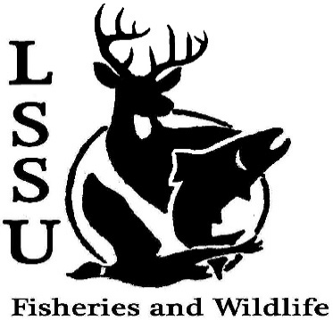
LSSU Fisheries and Wildlife Club

Meeting of November 1st, 2017

Call Time 8:00 pm

Officers

President: Will Marosi wmarosi@lssu.edu (313)-402-5261
Vice President: Riley Waterman
Secretary: Anna Bush
Treasurer: Cole VanOosten
Committee Chairs:
      - Fundraising- Nick Moorman
      - Events-Patrick James, Mary Markel
- Officer’s Report
  - Vice President – Riley Waterman
  - Secretary- Anna Bush Minutes
  - Treasurer – Cole VanOosten Report – white fish earnings
1st Mike 2nd JBD
- Old Business
  - Whitefish Dinner Very Successful
  - Meet and Greet with Charles Dawley GIS tech. And stewardship. Not just behind a desk
  - Atlantic Salmon netting – Atlantic's have sharp teeth, ARL-gill net, fin clips, tag some of the fish – lots of fun (Again Next Thursday)
  - Deer Shining – Good experience – Fun – see other animals and deer fighting... Want to do it next year – Possible Nov? But next year more opportunities
- New Business
  - Meet and Greet on November 2nd with Brian Schmidt USFWS Pizza, jobs opps. Lake sturgeons, coming a long way to come talk to us. Laker Hall 5:30
  - Potentially working with Girl Scouts Interested? (Poll)
  - Fish/Wildlife/Plant workshops? Looking to do some workshops – interested? Sign up sheet. (aging, fish ID, ID species – more lab stuff)
  - Trail Management Friday November 10th Help build pathways, job opportunities, pot luck lunch, (Send out email on where and Time)
  - Aquatic Plant ID Workshop Dec 14th Gaylord Mi
  - R Workshop Jan 21st Traverse City, Mi
  - Midwest Fish and Wildlife Conference Jan 28-31st Milwaukee, Wi
  - Have an idea for a speaker or a Meet and Greet at Laker Hall? Talk to Events committee or any of the officers!
  - Senior Research help? This Sat. And Sun. with Hadley with setting and collecting fish nets – meet after meeting to talk.
- Reminders
  - Please take photos and videos at FWC events!
  - Pay your dues!
  - Like the Facebook page!
  - Visit our Website! http://www.lssufwc.weebly.com/

Next Meeting: November 15th 2017

Close 8: 12 pm

1st Ethan 2nd Benny

