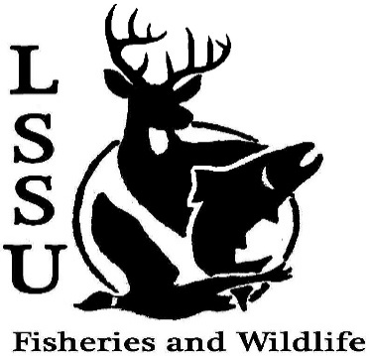
LSSU Fisheries and Wildlife Club
Meeting of October 19th, 2016
Called to Order @ 8pm. 1st by Mary, 2nd by Cole
Officers
President: Elizabeth Cilman ecilman@lssu.edu (989) 305-8599
Vice President: Juliet Golob
Secretary: Kelly Mildebrandt
Treasurer: Katherine Skubik
Committee Chairs:
      - Fundraising- Cliff Pattinson
      - Events-Riley Waterman
      - Apparel- Juliet Golob

- Officer’s Report
  - Vice President – Juliet Golob
  - Secretary- Kelly Mildebrandt 1st by Twan, 2nd by Cole
  - Treasurer – Katherine Skubik 1st by Graham, 2nd by Cole
- Old Business
  - GLSW Parade Presented by Kelly
  - Meet and Greet with Chris Olds Presented by Cole and Mike
- New Business
  - Apparel Forms and Money- Due before end of meeting
  - Climate Change Documentary- Thursday, October 20th 7:00pm (CRW207)
  - Owl Banding- Friday, October 21st
    - Presentation
    - Help with checking the nets
  - Cisco Tagging- Saturday, October 22nd
  - Birding workshop- Contact Maddy Almquist
    - Basics to birding and identification- Friday, October 28th 6:00pm (location TBA)
    - Birding- Saturday, October 29th 7:00am
(Location library parking lot)
  - Atlantic Broodstock Netting
    - Monday October 31st 11:00am-4:00pm
    - Tuesday November 1st 9:00am-12:00pm (or whenever there is enough fish caught)
  - Fish Dissection and Insect ID for High school Students (CRW257)- November 1st
    - Need Volunteers/someone to take charge
    - 1:30-2:30 or 10:30-1130 or 10:00-11:00
  - Laker Legion Box- with OAC and Fly Fishing Club November 4th Free food
  - Meet and Greet with Emily Martin F&W Biologist for Bay Mills Indian Community- Wednesday November 9th 5:30pm at laker hall
  - Whitefish Dinner Fundraiser- November 12th
    - Set up starts at 6:00pm
    - Two shifts- set up and clean up
    - Need silent auction items
  - Have an idea for an event? Talk to Events Committee or any of the Officers!
  - Have an idea for a speaker or a Meet and Greet at Laker Hall? Talk to Events committee or any of the officers!
  - Senior Research help?

- Reminders
  - Please take photos and videos at FWC events!
  - Pay your dues!
  - Like the Facebook page!
  - Visit our Website! http://www.lssufwc.weebly.com/

Next Meeting: November 2nd, 2016
Meeting Closed @ 8:25pm
1st by Patrick, 2nd by Cole

