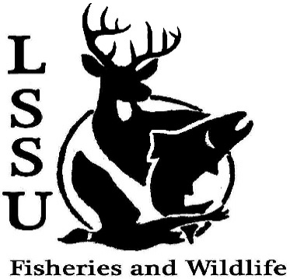
LSSU Fisheries and Wildlife Club
Meeting of October 5th, 2016
Called to Order @8:08pm
1st by Cole 2nd by Patrick
Officers
President: Elizabeth Cilman ecilman@lssu.edu (989) 305-8599
Vice President: Juliet Golob
Secretary: Kelly Mildebrandt
Treasurer: Katherine Skubik
Committee Chairs:
      - Fundraising- Cliff Pattinson
      - Events-Riley Waterman
      - Apparel- Juliet Golob

- Officer’s Report
  - Vice President – Juliet Golob
  - Secretary- Kelly Mildebrandt 1st by Cliff 2nd by Mary
  - Treasurer – Katherine Skubik 1st by Cole 2nd by Graham
- Old Business
  - Cisco Tagging Presented by Patrick
  - Biogames Presented by Juliet
  - Pine Pulling
  - Pond sampling
- New Business
  - Meet & Greet Chris Olds (USFWS Fisheries Biologist) – October 12 at Laker Hall @ 5pm
  - Raffle Blitz- October 8th at 3:30 4 pm, Contact Sara Ostwald (sostwald@lssu.edu) for details Meet in the library parking lot
  - Apparel- Order forms and money due at next meeting Presented by Juliet
  - GLSW Parade- October 15th 4:00pm
  - Owl Banding- Friday October 21st @ 5pm
    - Presentation
    - Help with checking the nets
  - Cisco Tagging- Saturday October 22nd Presented by Patrick. Meet @9:30
  - Birding workshop- Contact Maddy Almquist
    - Basics to birding and identification- Friday October 28th 6:00pm (location TBA)
    - Birding- Saturday October 29th 7:00am
(Location library parking lot)
  - Fish Survey/Sampling- Dr. Garvon
  - Laker Legion Box- with OAC and Fly Fishing Club Friday November 4th Food and drink provided
  - Whitefish Dinner Fundraiser- November 12th
    - Need silent auction items
  - Club Board is Complete- Thank You Maddy!
  - Have an idea for an event? Talk to Events Committee or any of the Officers!
  - Have an idea for a speaker or a Meet and Greet at Laker Hall? Talk to Events committee or any of the officers!
  - Senior Research help?

- Reminders
  - Please take photos and videos at FWC events!
  - Pay your dues!
  - Like the Facebook page!
  - Visit our Website! http://www.lssufwc.weebly.com/

Next Meeting: October 19th, 2016
Meeting Closed @ 8:37pm
1st by Cole 2nd by Jac

