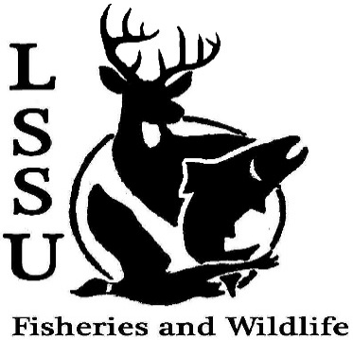
LSSU Fisheries and Wildlife Club
Meeting of January 18th, 2017
Called to Order @8pm
Officers
President: Elizabeth Cilman ecilman@lssu.edu (989) 305-8599
Vice President: Juliet Golob
Secretary: Kelly Mildebrandt
Treasurer: Katherine Skubik
Committee Chairs:
      - Fundraising- Cliff Pattinson Needs more help, meet at the end of the meeting, committee gathers raffle prizes (next one is MI AFS w/ MSU, currently have zero prizes
      - Events-Riley Waterman Always looking for more people, events, and meet and greets
      - Apparel- Juliet Golob Does not currently need help

- Officer’s Report
  - Vice President – Juliet Golob
  - Secretary- Kelly Mildebrandt
  - Treasurer – Katherine Skubik Dues came in, paid Whitefish dinner bill, explained petty cash (cash kept on hand)
Motion to approve by Twan, 1st by Patrick, 2nd by Cole
- Old Business
  - Winter break Kelly ate a sea urchin, Liz went sledding and ice fishing
  - Meet and Greet- Dave Jentoft
Wildlife Biologist from the Soo Field Office. Wants to coordinate with juniors and seniors to help with projects. He will be at the DNR sports club meeting, feel free to contact him
- New Business
  - Resume Workshop- Wednesday, January 25th 7pm-9pm Run by Dr. Moerke and Dr. Graham. In CRW 204 until further notice
  - Telemetry Workshop- Friday, January 27th 5-7pm Run By Maddie and Will. Will be taught how to use equipment, look for radio collars in Laker Woods
  - Midwest- February 5th-8th 4 students presenting → Joe: Didymo results with Dr. Moerke, Chris: Abundance of Muskie, Mike: Pitchers thistle and fledge rate of pipping plovers, Maddie: Agriculture affecting bees. Wish them luck!
  - Michigan AFS Conference- Tuesday-Thursday, March 14th-16th in Mackinaw City ( Mackinaw Beach and Bay Inn and Suites)
    - Abstracts- due February 17th
    - Early Registration Fee- due March 3rd, $50 for students
    - NEED raffle items- Two per club paid event
    - More detail can be found at: http://michigan.fisheries.org/annual-meeting/upcoming-meeting/
Need 2 raffle prizes→ Talk to Cliff or Nick, check to see if businesses were already talked to
  - MI TWS Annual Meeting- March 14th-16th Location TBA TWS is The Wildlife Society, Can become members, Lake State is a student chapter of TWS, Meeting is similar to Midwest, good chance to talk to professionals
  - Relay For Life- March 25th 11am-11pm 12 hour walk around the track, clubs can sell items at the walk, proceeds go to cancer research, theme is super hero, needs advanced notice of attendance
  - TWS Student Conclave- March 24th-26th Hosted by Purdue, Location unknown, more students than professionals, hands on demos including wolf calling, duck ID and telemetry
  - Snowy Owl Trip- Date TBA Suggested by Dr. Moerke and may be lead by her as well, more details to come, likely to be after February1st
  - Have an idea for an event? Talk to Events Committee or any of the Officers!
  - Have an idea for a speaker or a Meet and Greet at Laker Hall? Talk to Events committee or any of the officers!
  - Senior Research help?
Cliff→ Starting feeding trials soon, 5-10 minutes per day to feed, going down tonight if anyone wants to see the set up

Chicago Trip: Basically have too much money and want to treat the dues paying members to an event, thinking about Natural History Museum and/or Shedd Aquarium, more details to come, travel paid by the club, admission paid by students $57 at most for both
- Reminders
  - Please take photos and videos at FWC events!
  - Pay your dues! Find Katherine
  - Like the Facebook page!
  - Visit our Website! http://www.lssufwc.weebly.com/ Secretary minutes will be up soon

Next Meeting: February 1st, 2017

Closed @ 8:28
1st by Mary
2nd by Cole

