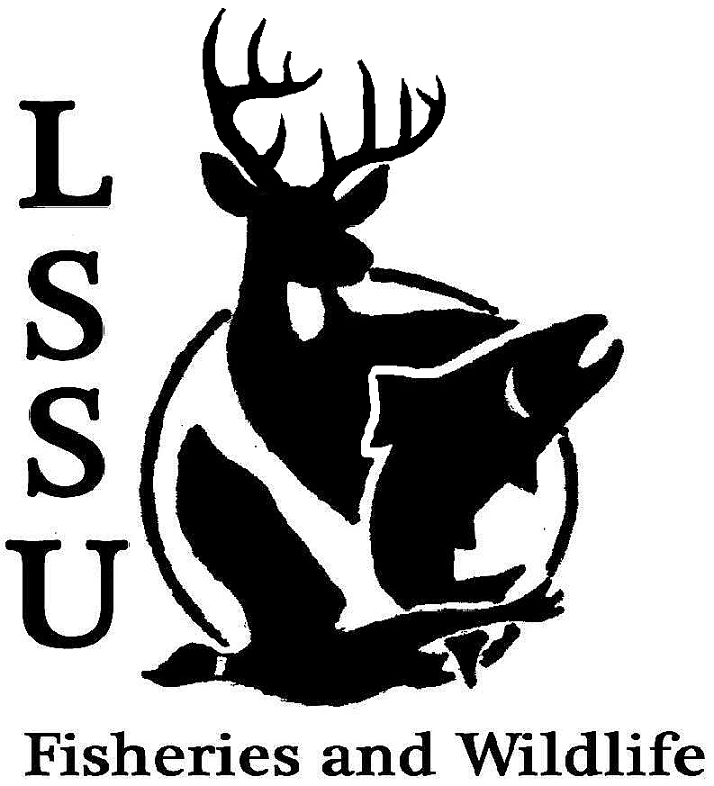
LSSU Fisheries and Wildlife Club
Meeting of February 18th, 2015
Kyle Hafeman: khafeman@lssu.edu (906) 295-1585

- Officers Report
  - Secretary – Addie Dutton Addie presented the minutes from the previous meeting. Motion to approve first by Autumn and second by Don. All approved
  - Treasurer – Jake Truitt Jake presented the current financial situation of the club. Motion to approve first by Coleson and second by Logan. All approved
  - Event Committee – Maddy and Gislaine, lssufwcevent@gmail.com
    - Katie Koch (Bird Conservation) – March 27th, 7pm, location TBA
    - MI Bird Conservation Workshop
      - March 19-21, Tustin, MI The girls talked about the past evens including the wildlife techniques workshop and that currently there is only one person signed up for the wildlife conclave, but it is a great opportunity for anyone interested in wildlife
  - Raffle Committee – Cliff
    - Raffle Blitz for F3T Please plan to help get raffle prizes especially if you are planning on attending either the Conclave or TWS meeting and getting club funding. Meet Saturday in the library parking lot at 10am and should only be two hours
- New Business
  - Midwest F&W Conference – Reimbursement The club approved first by Garret and second by Nate to reimburse Addie the full amount (hotel rooms and parking) for the trip to Indianapolis
  - Meet and Greet with Dan Traynor-Laker Hall, 7pm Dan is a fisheries tech with the MDNR and an alum. There will be snacks provided so please plan to attend and meet Dan.
  - Fly Fishing Film Tour – February 22st, 4pm Fine Arts Center
    - Date Changed!! Half of the proceeds from the F3T will go directly back to the club. If you are willing and able, please come and help out either set up, work the door, or security!
  - Ms. Purples class-Dissections! Feb 28th If you are able to help out, this should be a good time to get some community service in for the club and good for our application next year!
  - Doug Reeves Visit-March 11th presenting at the next meeting
    - Presentation at 4:30pm, CRW 305 Doug is the assistant chief of the wildlife division for the state of Michigan. If you have time plan to attend his presentation as he will be on campus most of the day. He is very easy to talk with an has an interest in making us good young professionals.
  - Nongame and Larval Fish ID Course – March 10th and 11th, MSU
    - Contact Kyle Hafeman for more information If you want to register for either of these, Kyle has the flyer.
  - MI TWS Meeting-March 26-27, Clare, MI
    - Student registration $25 before March 16th
  - TWS Student Conclave – March 27-29th, Sandstone MN
    - Registration is $80, first come first serve. 150 spots open These are clearly the same time so please consider what would be a better fit for you. Sign up sheets will be distributed and as talked about earlier, if you plan to use club funding it is important that you get raffle prizes as stated in the bylaws
  - New Officer Nominations
    - Elections Next Meeting
    - President
      - Chris Cortell-No
      - Trevor Dunn-No
      - Michelle Kane-No
      - Cliff Pattinson-Yes
      - Maddy Almquist-No
      - John Milan-No
      - Autumn Wiese-Yes
      - Scott Cooper-Yes
    - Vice President
      - Gessie Peters-No
      - Chris Cortell-Yes
      - Jess Haller-No
      - Michelle Kane-Yes
      - Paige Hall-Yes
      - Matt Grieb-Yes
      - Ben Osterland-Yes
    - Secretary
      - Katherine Skubik-No
      - Graham Peters-Yes
      - Alleigh Sexton-Yes
    - Treasurer
      - John Milan-Yes
      - Elizabeth Cilman-Yes
      - Drake Lefeur-No
      - Anthony Saximan-No
  - Senior Research help?
- Reminders
  - Please take photos at FWC events!
  - Pay your dues!
Next Meeting: Wednesday March 11th @ 8 PM
Meeting adjourned at 8:43 pm

