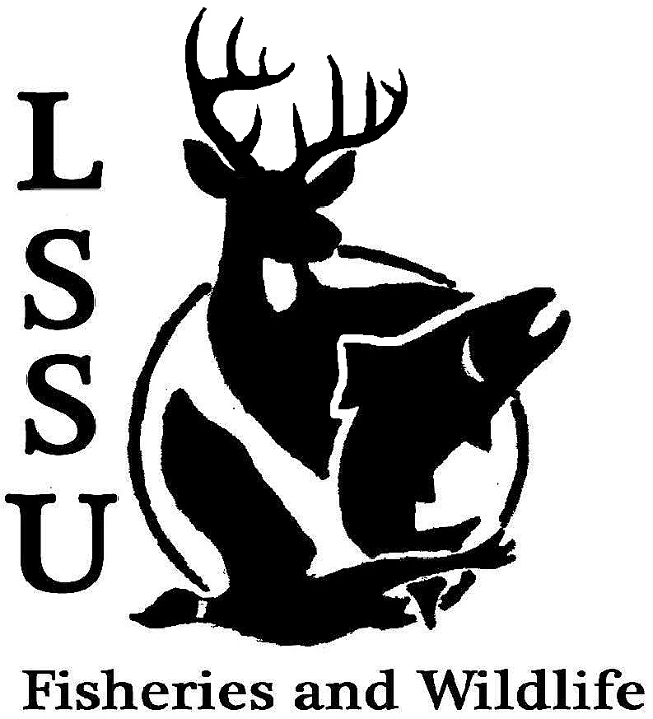
LSSU Fisheries and Wildlife Club
Meeting of April 8th, 2015
Clifford Quinn Pattinson: cpattinson@lssu.edu (269) 841-6472

- Officers Report
  - Vice President – Michelle Kane
  - Secretary – Autumn Wiese
  - Treasurer – John Milan
  - Events Committee – Maddy Almquist and Gislaine Peters, lssufwcevent@gmail.com
    - Sharp-Tailed Grouse Survey - http://www.fws.gov/refuge/seney/events/STGR_survey.html
    - Whitefish Point Bird Observatory

- Past Events
  - Dinner and Meet-and-Greet with Pete Butchko
  - Past Conferences

- New Business
  - Changes in By-Laws:
    - Announce and discuss today
    - Vote on changes next meeting
  - R.O.C. Fly Tying Workshop – April 10th at 6pm, $20 entry fee, total 10 spots open
  - Fly Casting Clinic – April 11th, Time and Location TBA
  - Chili Cook-off – April 15th, Crawford lobby, Contact officers or Cliff
  - R.O.C. Smelt Dipping and possible camp-out – April 18th
  - Earth Day – April 22nd, Festivities, possible table – contact Cliff, Addie or Dr. Glowinski
  - Possible Workshops/Events/Activities before year is done. – Leaders/coordinators

  - 2015-2016 Meeting Time Poll - https://www.surveymonkey.com/s/LDDSPCK

  - Call for Committee Chairs/Members – Volunteers? (Contact Cliff for details)

  - Summer Fishing Contest
  - Laker Hall opening – 1 new girl vacancy available
  - Crawford Lobby Proposal
  - Senior Research help?
  - Outstanding Club Member of the Year

- Reminders
  - Please take photos at FWC events!
  - Pay your dues!
  - Visit our Website! http://www.lssufwc.weebly.com/

Next Meeting: Wednesday April 22nd @ 8 PM
(LAST MEETING OF THE YEAR!!)

